Enterprise Program Management office (EPMO)
GuessLow
Administrator User Manual
September, 2026
Version: 1.0

Revision History
Version | Date | Author | Description
1.0 | 02/09/26 | Tony Solomon | Initial creation

Document Control
Document Information | Remark
Document Owner | Nib International Bank S.C - EPMO
Issued Date | 02/09/26
File Name | GuessLow - Administrator User Manual

Document History
Version | Date | Change
V.1.0 | 02/09/26 | Initial creation

Document Author
Name | Position | Department | Sign
Tony Solomon | Junior Software Engineer | EPMO
Aliy Umer | Junior Software Engineer | EPMO

Document Reviewer
Name | Position | Department | Sign
Gebreab Dagne | Principal Project Control and QA Officer | EPMO

Document Validator
Name | Position | Department | Sign
Fiseha Tesfaye | EPMO – Senior Director | EPMO

Table of Contents
Revision History ii
Document Control iii
Table of Contents iv
Acronyms vii
1. Introduction 1
1.1 Purpose 1
1.2 Who This Manual Is For 1
1.3 How the Auction Works 1
1.4 What You Will See 1
2. Signing In 3
2.1 Changing Your Password 3
3. The Dashboard 4
3.1 The Attention Band 4
3.2 The Tiles 5
3.3 Charts and Shortcuts 5
4. Auctions 6
4.1 Creating an Auction 7
Bidding rules explained 8
4.2 Publishing an Auction 9
4.3 Watching a Live Auction 10
4.4 Restricting Who May Bid 11
Using a saved list 12
Uploading a one-off list 12
4.5 Settling an Auction and Publishing the Result 12
4.6 When an Auction Has No Winner 14
4.7 Re-Auctions and Carried-Forward Bids 15
4.8 Editing an Auction 16
5. Bids 17
6. Winners 18
6.1 The Claim Lifecycle 18
6.2 Acting on a Winner 19
7. Payments 20
7.1 How Fee Collection Works 20
7.2 Resolving a Transaction 21
8. Items and Categories 22
8.1 Adding an Item 23
8.2 Categories 24
8.3 Uploading Pictures 24
9. Content 25
9.1 Banners 25
9.2 Ads 26
9.3 Terms and Conditions 27
9.4 Participant Lists 28
9.5 Branding 28
10. Bidders 29
10.1 Suspending or Blocking an Account 30
11. Notifications 32
11.1 Message Templates 32
11.2 The Delivery Log 33
12. Approvals 35
13. Reports 36
14. Audit Logs 38
15. Managing Staff Accounts 40
15.1 Users 40
Creating an account 40
Removing access 41
15.2 Access Control 41
Changing what a role can do 42
The roles supplied with the platform 42
16. Settings 44
16.1 Keeping Auctions Moving 45
17. Reference 47
17.1 Auction Statuses 47
17.2 Bid Statuses 47
17.3 Payment Statuses 47
17.4 Winner Statuses 48
17.5 Customer Account Statuses 48
17.6 Common Questions 48
Approvals 49

Acronyms
Term | Definition
Bid service fee | The charge a customer pays for each bid placed.
Bidder | A customer account in the mini-app.
Console | The staff-facing side of GuessLow, used to run the platform.
CSV | A plain spreadsheet file, used for exports and participant lists.
ETB / Br | Ethiopian Birr, the currency all amounts are shown in.
Maker-checker | A control requiring a second person to approve a change.
Mini-app | GuessLow as customers see it inside the super app.
Module | One area of the console, such as Auctions or Winners.
Re-auction | A fresh round of an auction that closed without a winner.
Role | A named set of permissions assigned to a staff account.
Settlement | Working out and publishing an auction result.
SMS | Short Message Service, used for customer notifications.

1. Introduction

1.1 Purpose
This manual explains how to run GuessLow from the operations console: creating and publishing auctions, following results, handling winners and payments, managing customers and staff, and configuring the platform.

1.2 Who This Manual Is For
Staff of Nib International Bank who operate, support or oversee GuessLow. Customers should refer to the GuessLow Customer User Manual.

1.3 How the Auction Works
GuessLow is a lowest unique bid auction. The winner is the participant holding the lowest amount that nobody else submitted. The lowest bid does not automatically win — only the lowest unique one does.
For example, if bids of 1.00, 2.00, 3.00 and 4.00 Br are received, and 1.00 and 3.00 were each chosen by two people, then only 2.00 and 4.00 are unique. The lower of those, 2.00 Br, wins.
Customers pay a bid service fee for every bid. The bid amount itself is only paid by the winner, in addition to the fee.
A rule that shapes the whole console. Bid amounts are hidden from everyone, staff included, until an auction has been settled. If the amounts were visible while an auction ran, anyone who could see them would know which amount would win.

1.4 What You Will See
The console groups its work into five areas in the left-hand menu. You only see the areas your role allows.
Group | Modules
Operations | Dashboard, Auctions, Bids, Winners, Payments
Catalog | Items, Categories, Content
Customers | Bidders, Notifications
Governance | Approvals, Reports, Audit Logs
System | Users, Access Control, Settings

2. Signing In
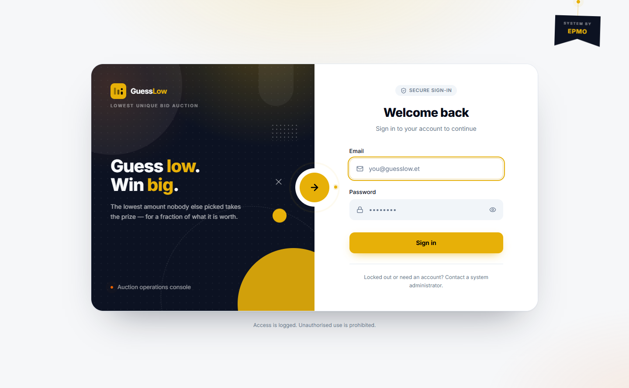
Figure 2.1: The console sign-in screen.
- Open the console address in your browser.
- Enter your work email address and your password.
- Select Sign in.

A few points to be aware of:
- The message shown for a wrong password is the same as for an unknown email address. This is deliberate, so the form cannot be used to discover which accounts exist.
- Repeated failed attempts lock the account for a period set under Settings.
- A new account, or one that has been issued a one-time password, must set a real password before it can go anywhere else.

2.1 Changing Your Password
Use the Change password screen. If you have forgotten your password, ask a Super Admin to issue you a one-time password from the Users module.

3. The Dashboard
The dashboard is the daily starting point. It shows what is running, what has happened today, and what is waiting for a decision.
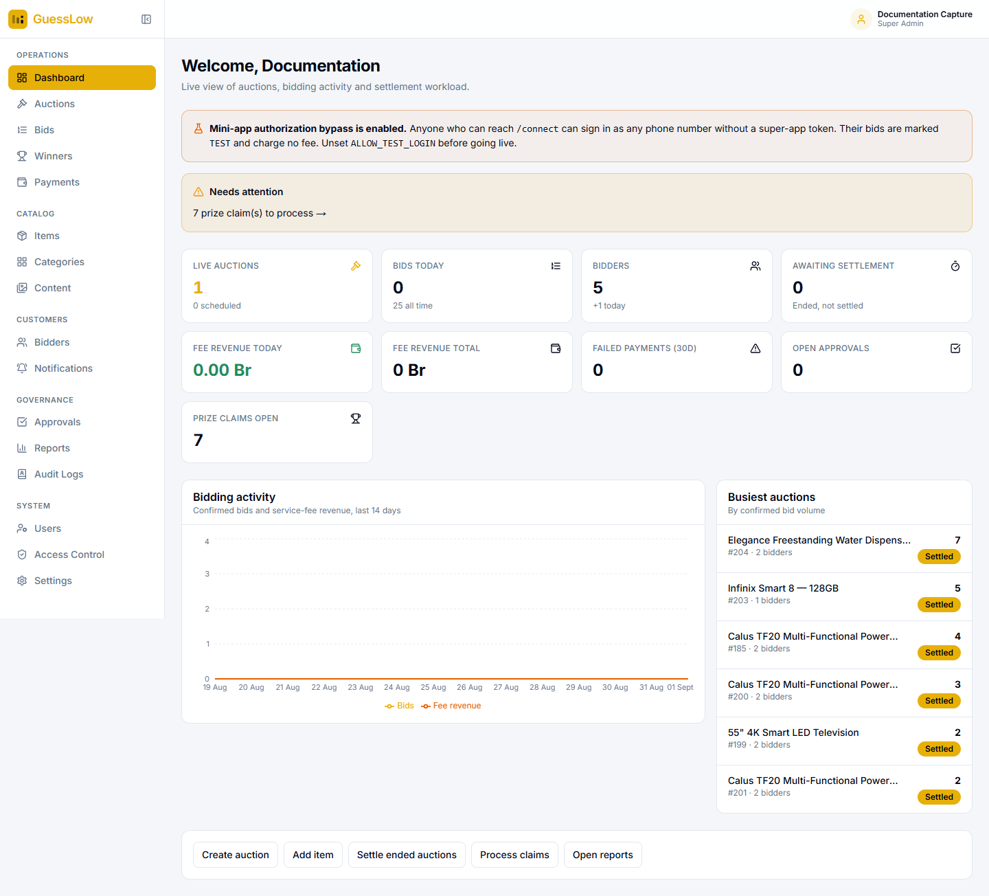
Figure 3.1: The dashboard. The work needing attention sits above the chart.

3.1 The Attention Band
A band directly under the title links straight to work that is waiting — in the example above, seven prize claims to process. Select it to go to the module concerned.
A second band appears when the mini-app sign-in bypass is switched on, warning that anyone who can reach the app can sign in as any phone number. This must be switched off before the platform is opened to the public.

3.2 The Tiles
Tile | What it tells you
Live auctions | How many auctions are running, and how many are scheduled to follow.
Bids today | Confirmed bids today, with the all-time total underneath.
Bidders | Registered customers, and how many joined today.
Awaiting settlement | Auctions that have ended but whose result has not been published.
Fee revenue today / total | Service fee income collected.
Failed payments (30d) | Fee collections that did not complete in the last 30 days.
Open approvals | Changes waiting for a second person to approve.
Prize claims open | Winners who have not yet completed a claim.

3.3 Charts and Shortcuts
Bidding activity charts confirmed bids and fee revenue over the last 14 days. Busiest auctions ranks auctions by confirmed bid volume. The buttons along the bottom jump to the common tasks: create an auction, add an item, settle ended auctions, process claims and open reports.

4. Auctions
An auction moves through the following states:
Status | Meaning
Draft | Created but not visible to customers.
Pending approval | Waiting for a second person to approve publication.
Scheduled | Published, but the start time has not been reached.
Live | Accepting bids.
Ended | Closed to bids, result not yet published. Amounts remain hidden.
Settled | Result worked out and published. Amounts are now visible.
Cancelled | Withdrawn. An auction that has been public is cancelled, never deleted.

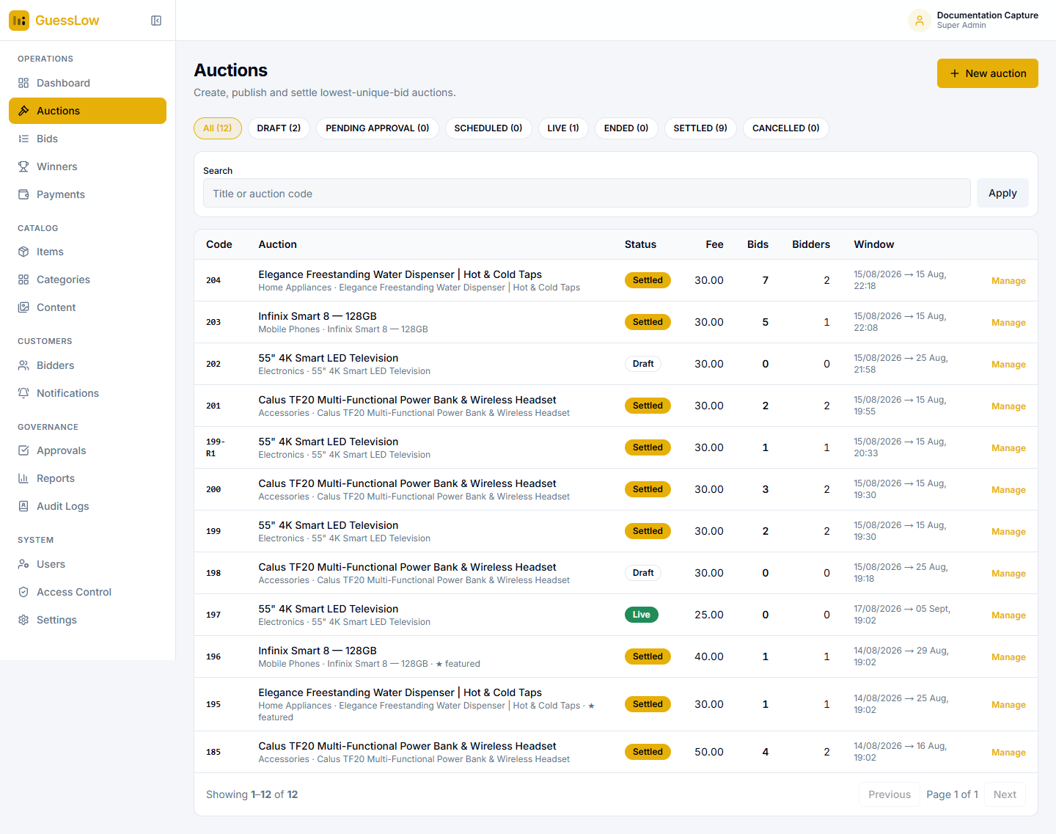
Figure 4.1: The auction list. The chips along the top filter by status and carry a live count each.
Search by title or auction code. Each row gives the auction code, item and category, status, bid fee, how many bids and distinct customers it drew, and its window. Select Manage to open an auction, or New auction to start a draft.

4.1 Creating an Auction
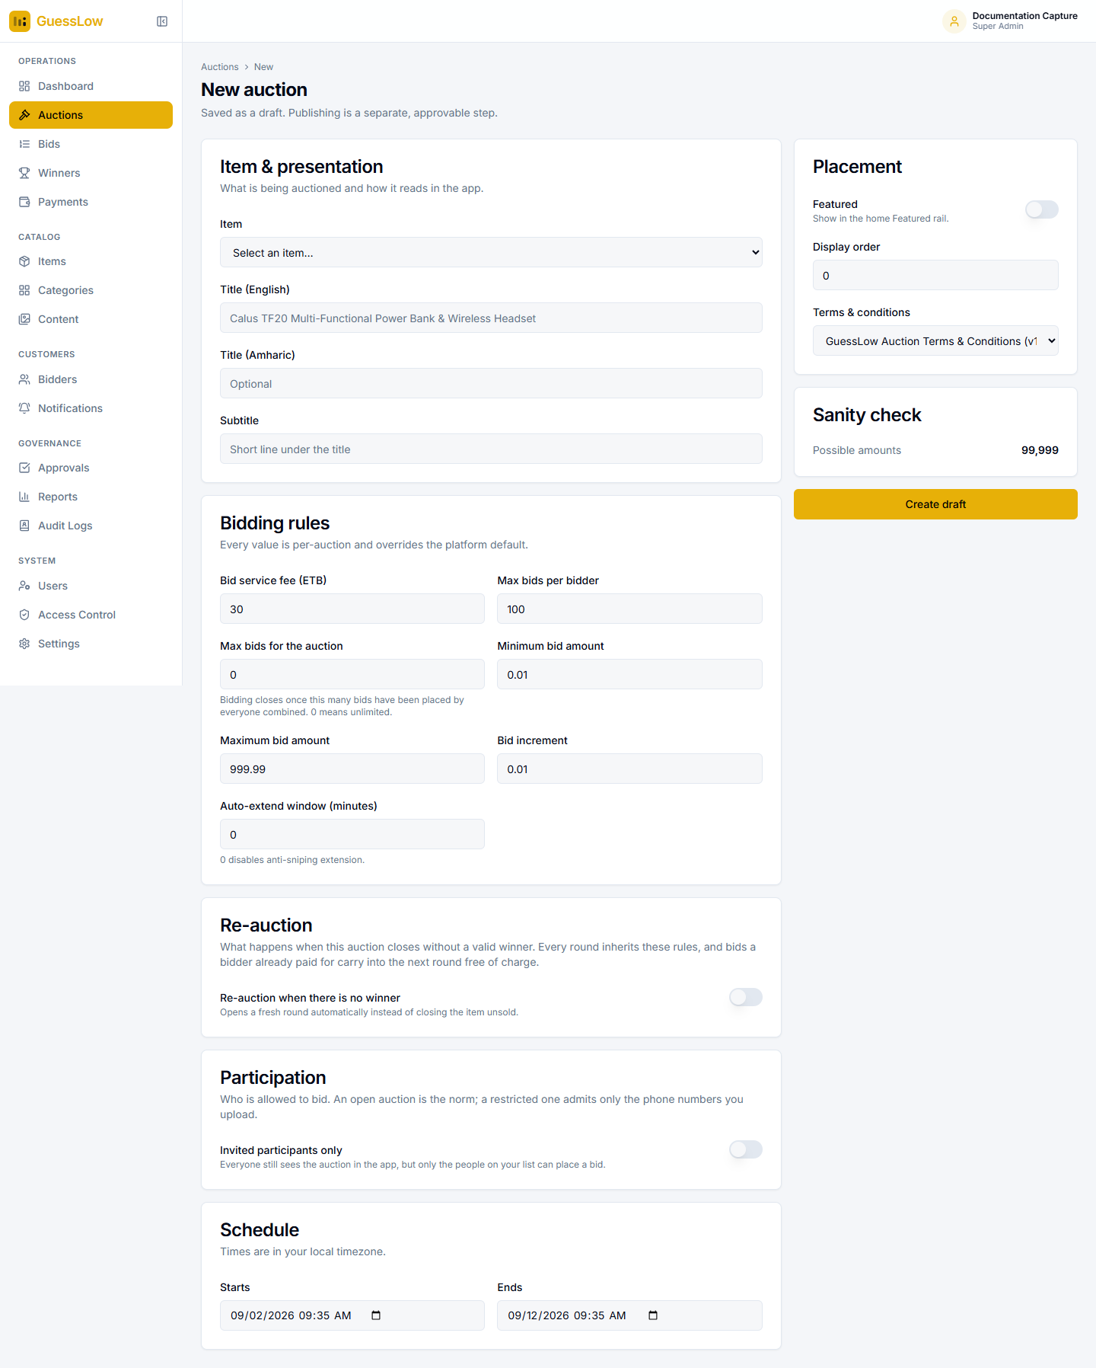
Figure 4.2: The New auction form. It saves as a draft — publishing is a separate step.
- Go to Auctions and select New auction.
- Under Item & presentation, choose the item from the catalogue. The English title fills in from the item; you can change it and add an Amharic title and a subtitle.
- Under Bidding rules, set the bid service fee, the maximum bids per customer, the maximum bids for the auction as a whole, the lowest and highest bid amounts, and the increment.
- Set the auto-extend window if you want late bids to push the closing time out. Enter 0 to switch it off.
- Under Re-auction, decide whether the auction should be run again if it closes with no winner.
- Under Participation, leave the auction open, or restrict it to an invited list of phone numbers.
- Under Schedule, set the start and end times.
- On the right, mark the auction as Featured if it should appear on the home screen, set the display order, and choose which version of the terms and conditions applies.
- Read the Sanity check panel, then select Create draft.

Read the Sanity check before you publish. It reports how many different amounts the bid range and increment actually allow, and the number of bids needed to break even. A narrow range with many customers produces duplicates everywhere and auctions that end with no winner at all.

Bidding rules explained
Field | What it does
Bid service fee | What each bid costs the customer.
Max bids per bidder | How many bids one customer may place on this auction.
Max bids for the auction | Bidding closes once this many bids have been placed by everyone combined. 0 means unlimited.
Minimum / maximum bid amount | The range customers may choose within.
Bid increment | The step amounts must land on. With 0.01, an amount of 4.75 is valid and 4.752 is not.
Auto-extend window | A bid placed within this many minutes of the close pushes the closing time out by the same amount. 0 switches it off.

4.2 Publishing an Auction
A draft becomes visible to customers when it is published. If maker-checker is switched on for publishing, the auction moves to Pending approval and a second person must approve it from the Approvals module.

4.3 Watching a Live Auction
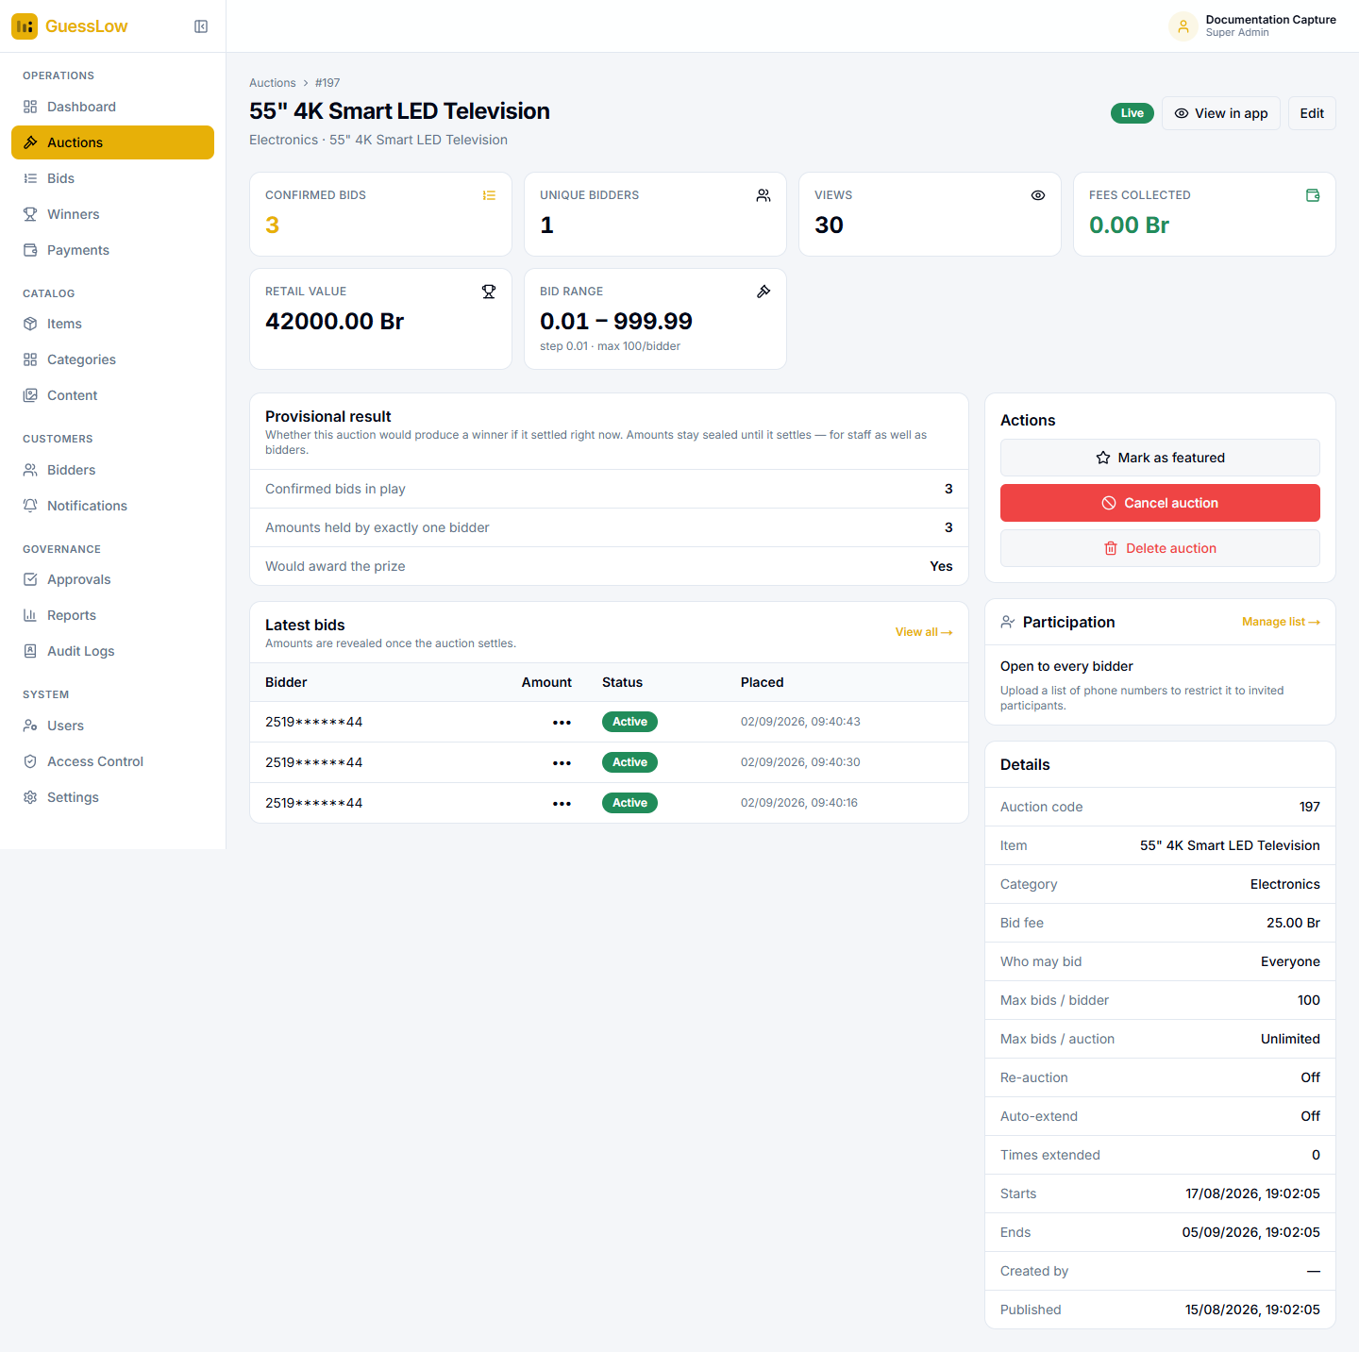
Figure 4.3: A live auction. Amounts are hidden, and the Provisional result panel reports the shape of the outcome without them.
The Provisional result panel answers the only question worth asking while an auction is running — would it produce a winner if it closed right now — without revealing the amounts:
Row | Meaning
Confirmed bids in play | Bids whose fee has been collected.
Amounts held by exactly one bidder | How many amounts are currently unique.
Would award the prize | Whether a winner exists at this moment.

The Latest bids table below shows who bid and when, with the amount shown as dots. The Actions panel offers Mark as featured, Cancel auction and Delete auction. Participation shows whether the auction is open or restricted, and Details lists the full rule set.
Economics lock once bidding starts. The fee and the bid range cannot be changed after the first bid is placed. Changing them mid-auction would retroactively invalidate bids customers have already paid for.

4.4 Restricting Who May Bid
Open an auction and select Manage list in the Participation panel.
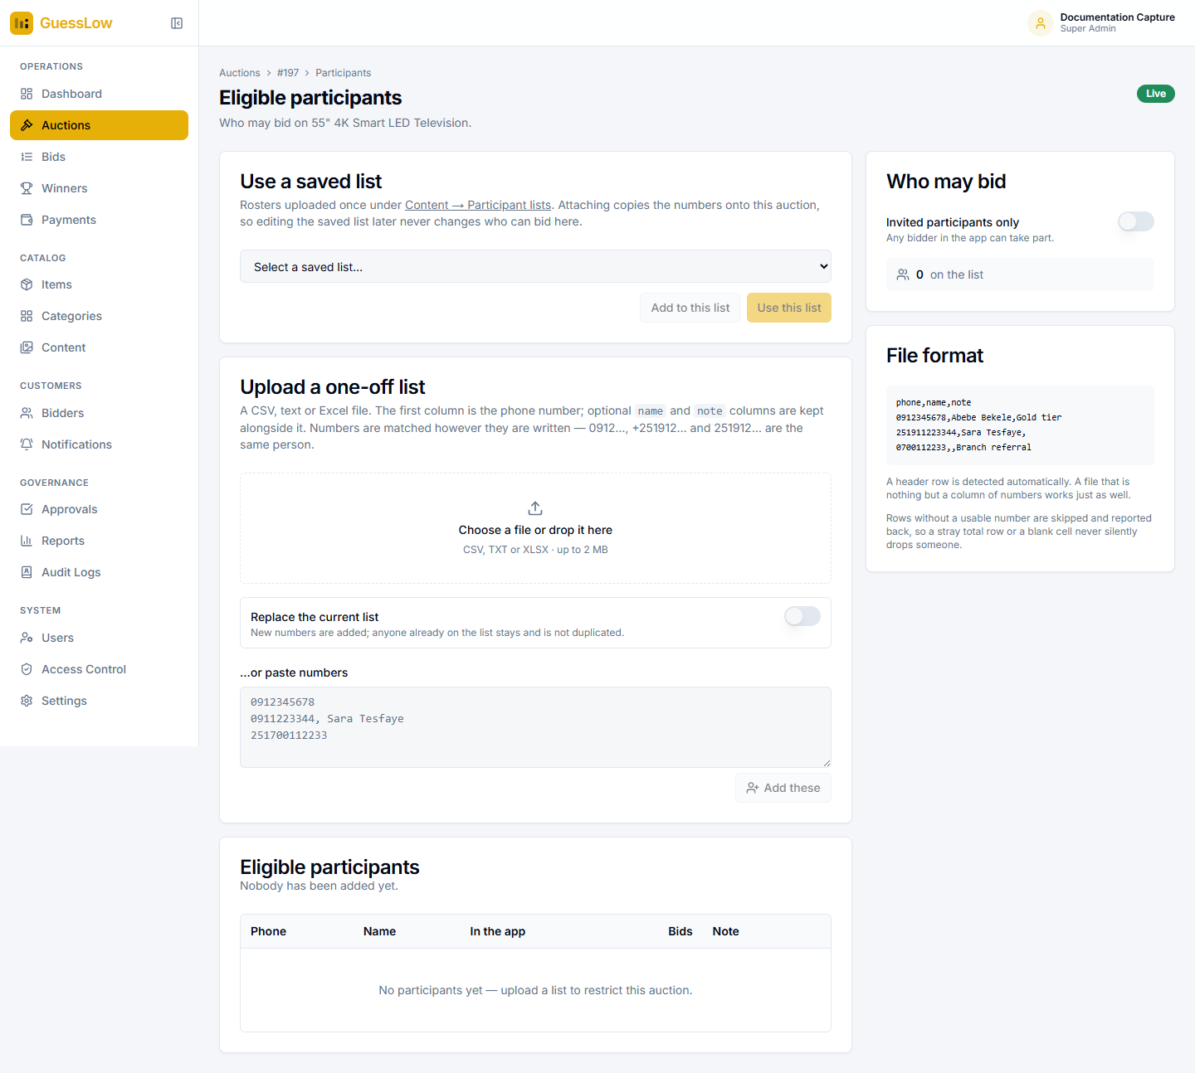
Figure 4.4: Eligible participants — three ways to say who may bid on an auction.

Using a saved list
Lists uploaded once under Content → Participant lists appear in the picker. Add to this list appends them; Use this list replaces what is there.
Attaching a list copies it. Editing the saved list afterwards never changes who can bid on this auction — which is what you want, because eligibility on a running auction should not change under customers’ feet.

Uploading a one-off list
- Prepare a CSV, TXT or XLSX file of up to 2 MB. The first column is the phone number; optional name and note columns are kept alongside it.
- Drop the file onto the upload area, or select it with the file picker.
- Leave Replace the current list switched off to add to the existing list, or switch it on to start again.
- Switch on Invited participants only in the Who may bid panel. Until you do, the list is stored but the auction stays open to everyone.

Numbers are matched however they are written — 0912…, +251912… and 251912… are treated as the same person. Rows without a usable number are skipped and reported back, so a stray total row or a blank cell never silently drops someone. You can also paste numbers straight into the box, one per line.

4.5 Settling an Auction and Publishing the Result
When an auction ends, GuessLow works out the result automatically after the grace period set under Settings, and publishes it. An operator can also settle an auction by hand from the auction page.
Settlement takes every bid whose fee has been confirmed, groups the bids by amount, keeps the amounts held by exactly one customer, and ranks those from lowest upwards. Rank 1 wins. A winner record is created with a claim deadline, and the auction moves to Settled.
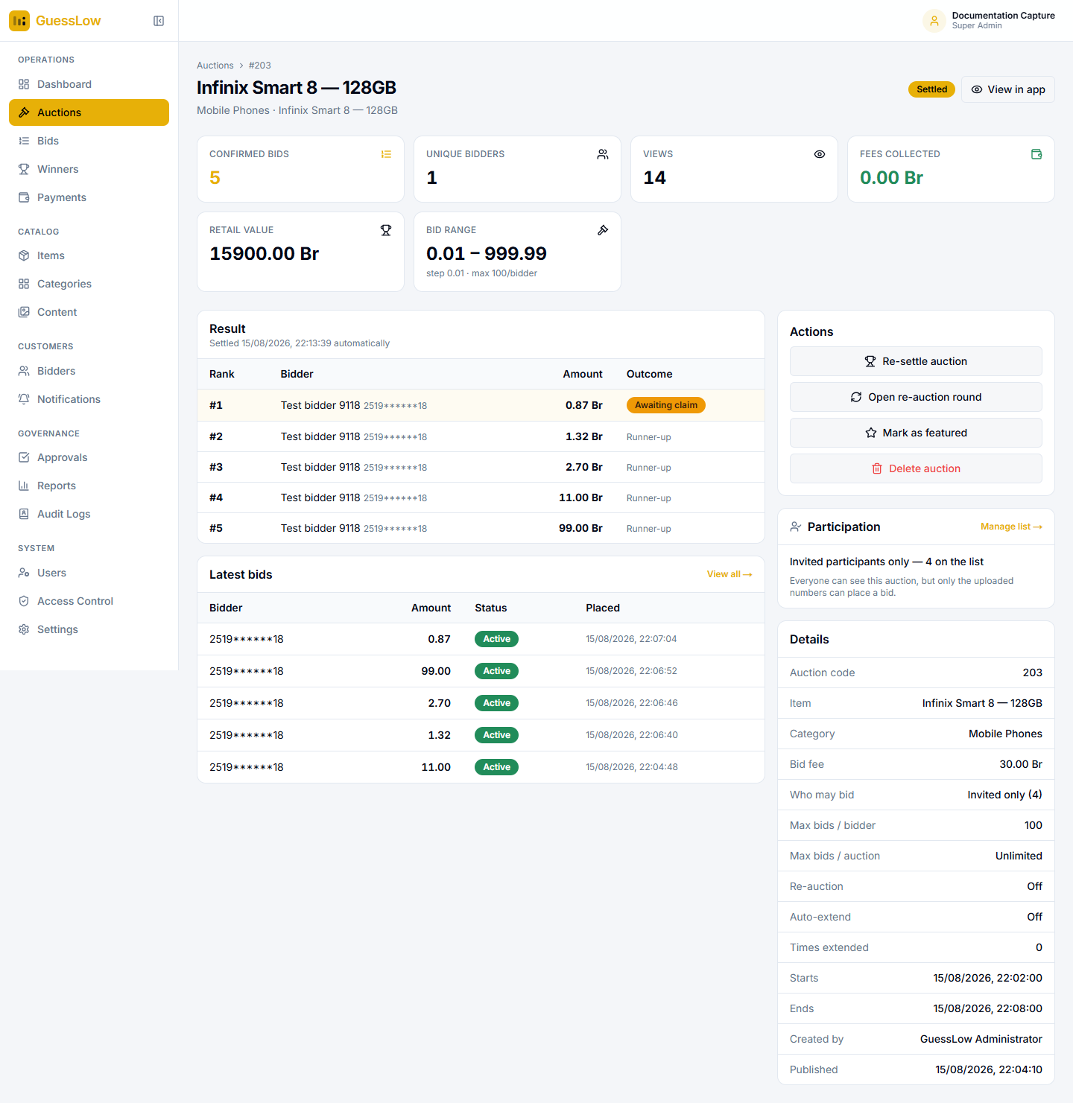
Figure 4.5: A settled auction. The result table is now fully open — rank, bidder, amount and outcome.
The Actions panel now offers:
- Re-settle auction — discards the published result and works it out again. Use this after a dispute.
- Open re-auction round — starts the next round by hand.
- Mark as featured and Delete auction.

Settling and re-settling can both be routed through maker-checker, so that a second person must approve them.

4.6 When an Auction Has No Winner
An auction closes without a winner when no amount was chosen by exactly one person, or when fewer bids were received than the minimum you set for a valid result. The item is not awarded.
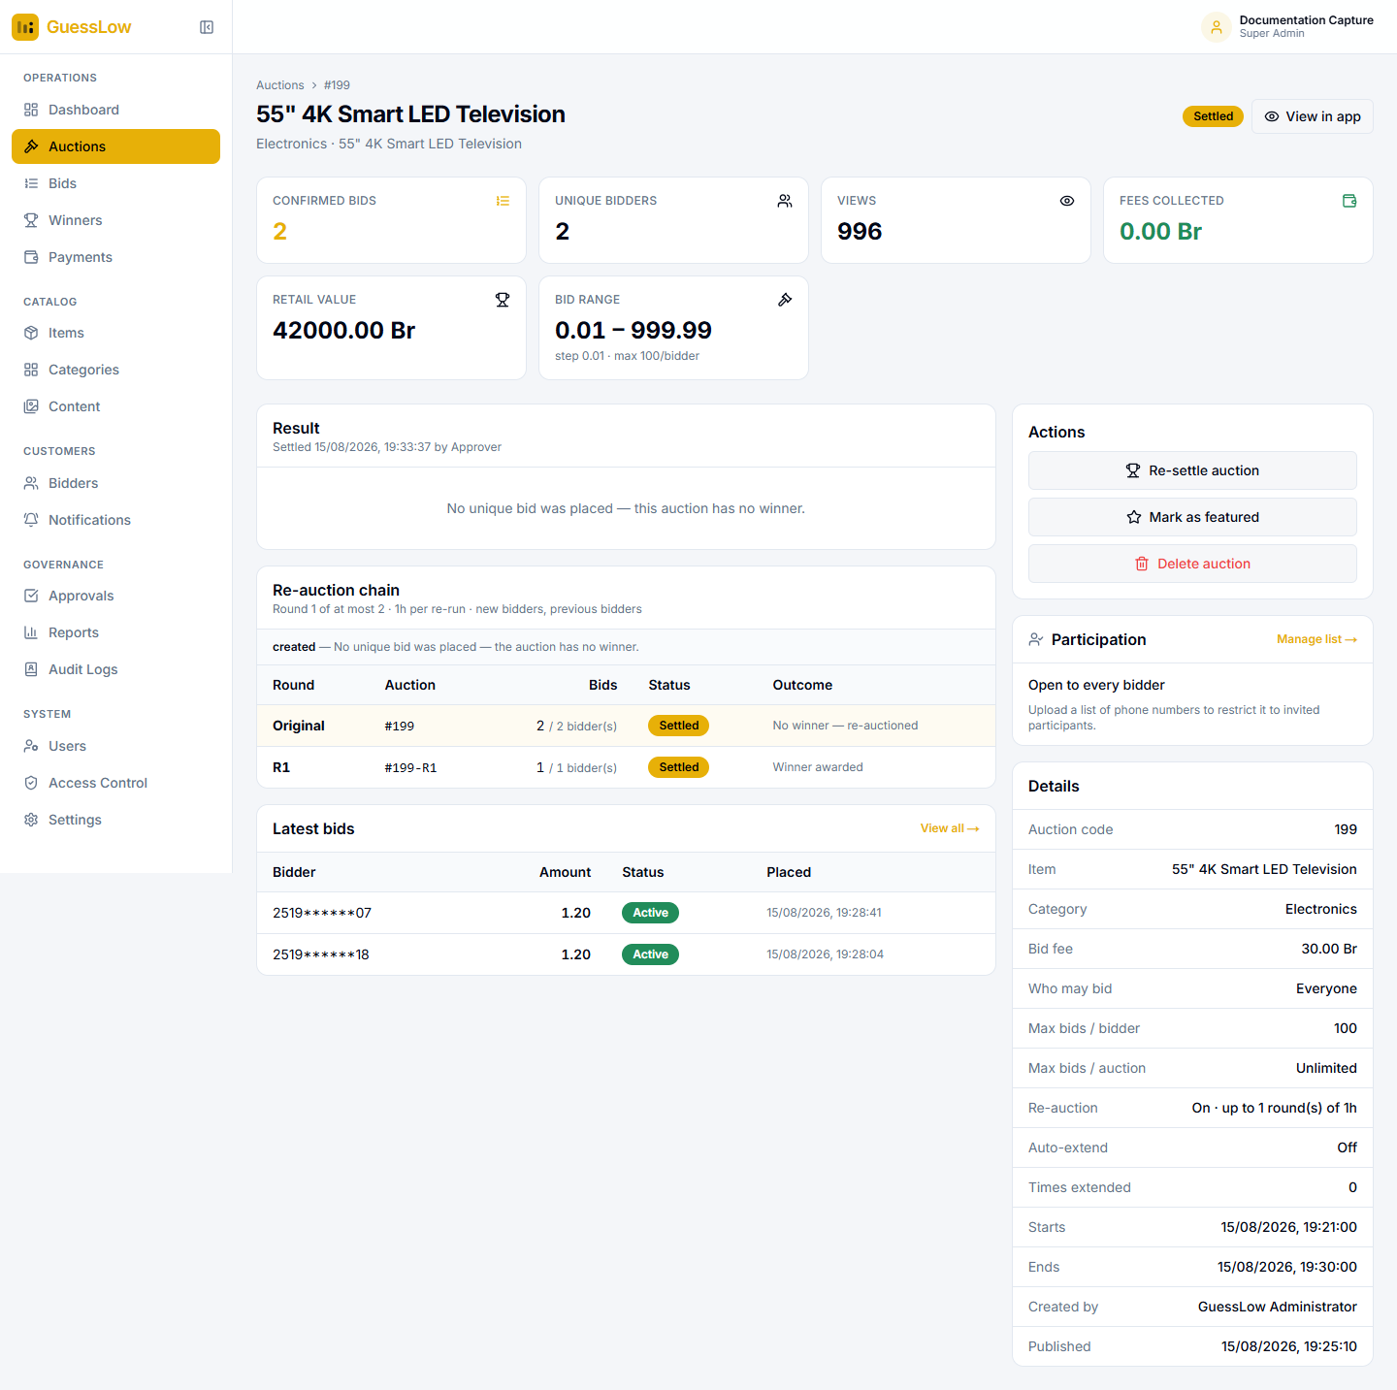
Figure 4.6: Auction #199 closed with no winner because both customers bid 1.20 Br. The re-auction chain shows the round that resolved it.
This example contains the whole rule. The auction took two confirmed bids and both were 1.20 Br, so no amount was unique and the result panel reads "No unique bid was placed — this auction has no winner."
The Re-auction chain panel below shows what happened next:
Round | Auction | Bids | Status | Outcome
Original | #199 | 2 / 2 bidders | Settled | No winner — re-auctioned
R1 | #199-R1 | 1 / 1 bidder | Settled | Winner awarded

The line above the table states the rules of the chain — how many rounds are allowed, how long each runs, and who may take part — so you can see at a glance what remains.

4.7 Re-Auctions and Carried-Forward Bids
A re-auction is a fresh auction for the same item, linked to the original and carrying a code that extends it: 199 becomes 199-R1, then 199-R2.
Nobody pays twice. Every bid a customer has already paid for anywhere in the chain becomes a free bid in the new round. If they paid for 5 bids and place 8 in the re-run, 5 are free and 3 are charged. Across the whole chain a customer only ever pays for the largest single round they played.

Everyone from the previous round is notified when a new round opens — that the auction is being re-run, how many paid bids came with them, and from which bid a fee starts again. Customers excluded from a round are told that instead.
Whether rounds open and publish by themselves is set under Settings → Re-Auction. With automatic creation switched off, the auction is flagged as pending and an operator opens the next round from the auction page.

4.8 Editing an Auction
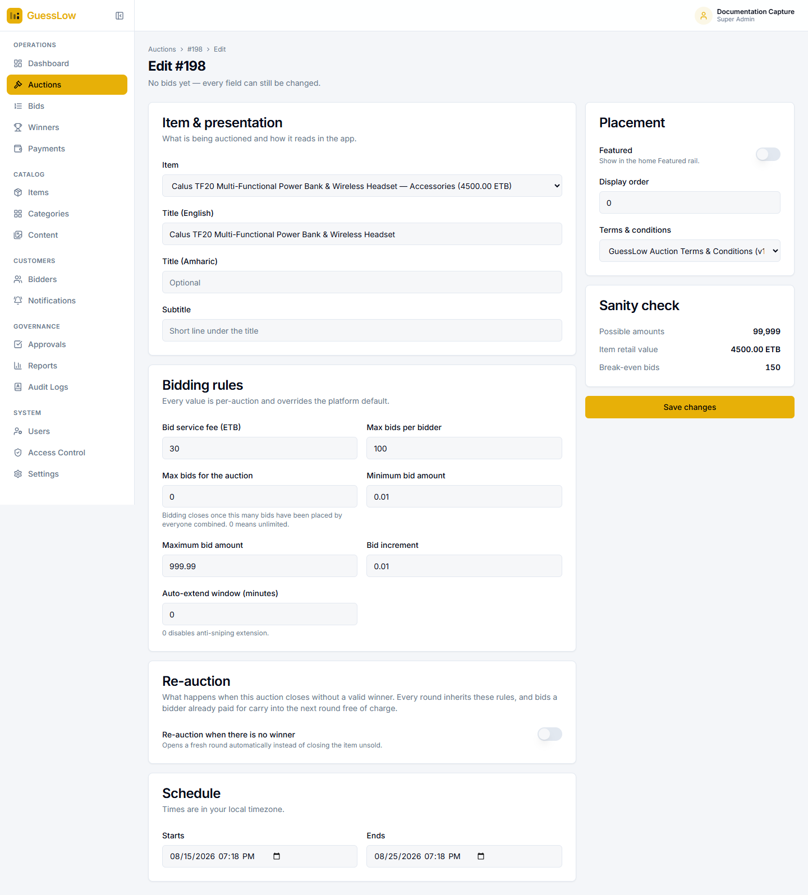
Figure 4.7: Editing an auction. Fields that would invalidate existing bids are locked once bidding has started.

5. Bids
The Bids module lists every bid placed on the platform, including attempts whose fee was never collected.
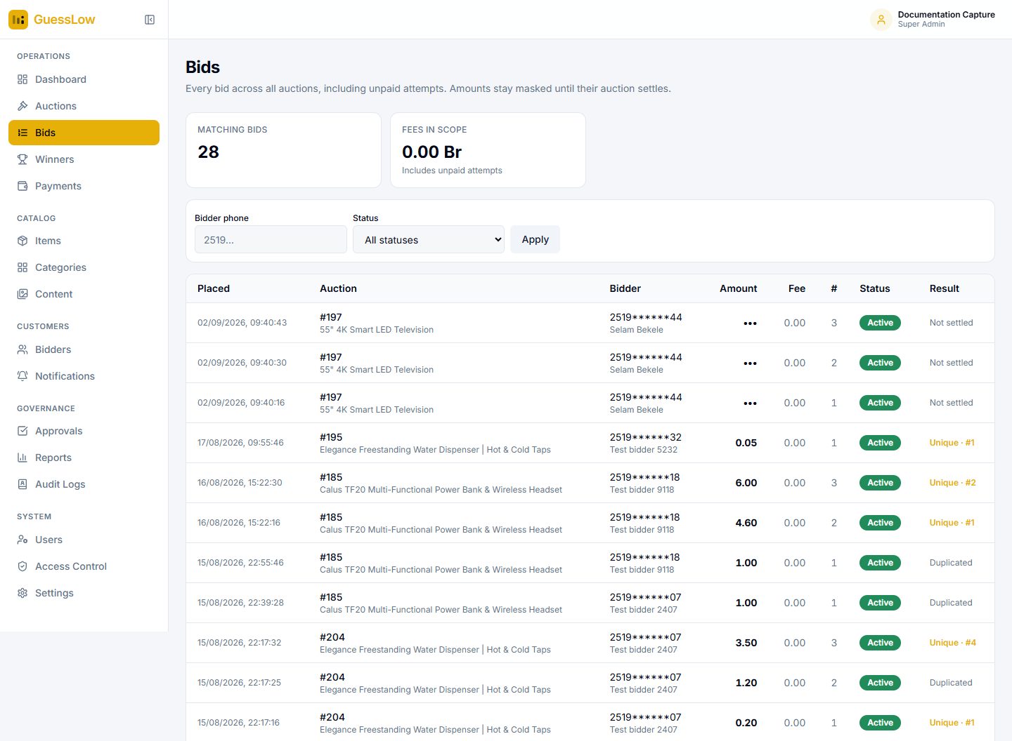
Figure 5.1: The Bids table. The three live bids at the top are masked and marked "Not settled"; every settled bid below shows its amount and result.
This single view shows the confidentiality rule in action. Bids on a running auction appear as dots with the result "Not settled". Bids on a settled auction show the amount, and the result reads Unique with a rank for amounts only one person chose, or Duplicated for amounts two or more people chose — which is exactly why those bids lost.
Filter by customer phone number or by status and select Apply. The tiles above count the matching bids and the fees within that selection. The # column is the customer’s own bid number on that auction — their first, second, third and so on.

6. Winners
The Winners module carries prize claims from announcement through to delivery.
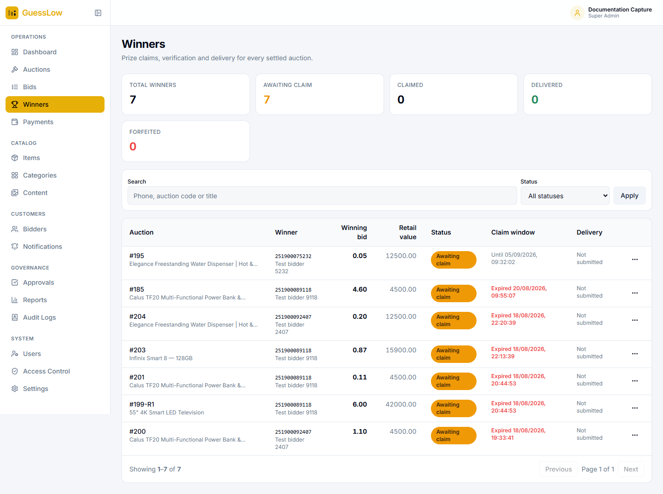
Figure 6.1: The Winners module. Claim windows that have passed are shown in red.
The tiles count total winners, those awaiting a claim, those claimed, delivered and forfeited. The table lists each winner with the auction, the winning bid, the retail value of the prize, the claim status, the claim window and the delivery state.

6.1 The Claim Lifecycle
Status | Meaning | What you do
Awaiting claim | The winner has been notified and the claim window is open. | Wait, or send a reminder.
Claimed | The winner has submitted their claim and delivery details. | Verify their identity and details.
Verified | The claim has been checked and accepted. | Arrange delivery and record it.
Fulfilled | The prize has been delivered. | Nothing further.
Forfeited | The claim window closed with no claim. | Optionally promote the runner-up.

6.2 Acting on a Winner
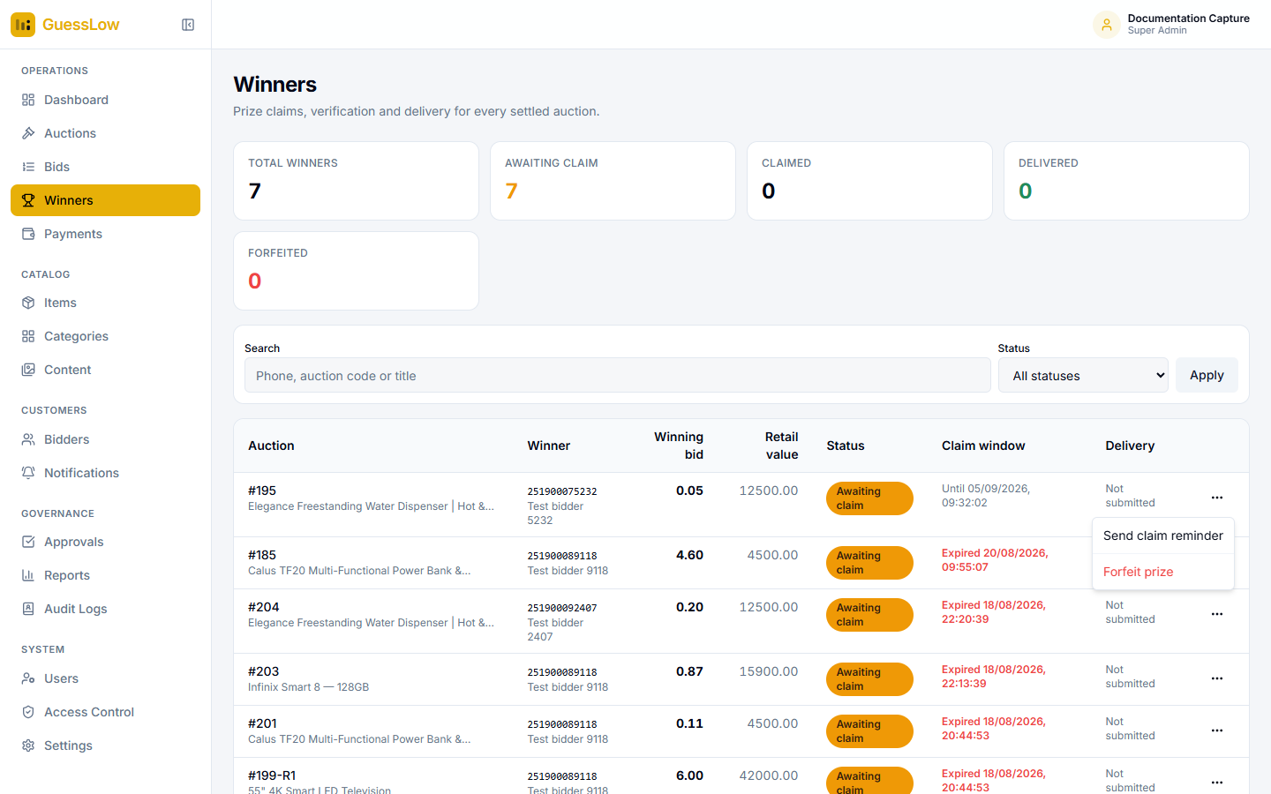
Figure 6.2: The menu on each row carries the actions available at that stage.
- Find the winner in the table, filtering by status or searching by phone number, auction code or title.
- Open the menu at the end of the row.
- Choose the action — for a winner still awaiting a claim, that is Send claim reminder or Forfeit prize.

7. Payments
Payments is where bid service fees collected through the super-app wallet are reconciled.
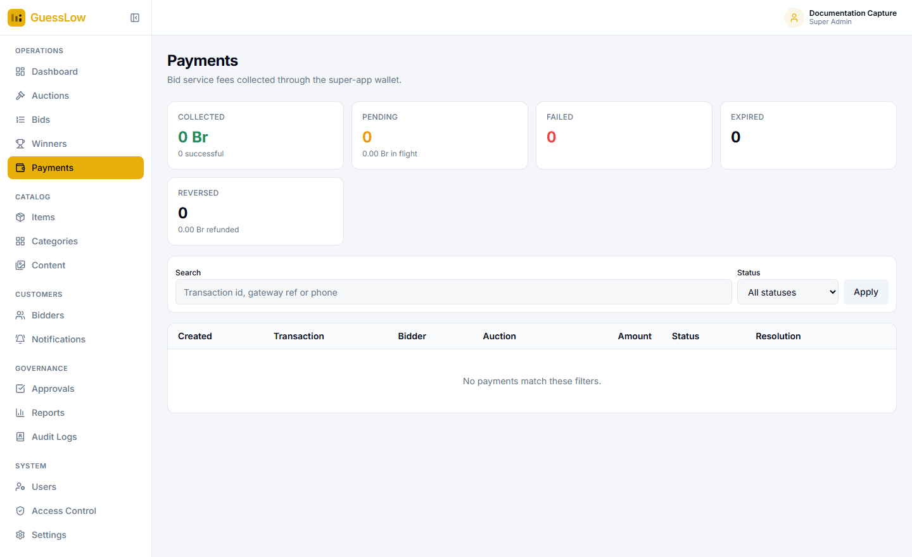
Figure 7.1: The Payments module. The table is empty here because every bid in this environment was placed in a test session, which collects no fee.
The tiles count collected, pending, failed, expired and reversed transactions, each with its value. Search by transaction reference or phone number, and filter by status.

7.1 How Fee Collection Works
When a customer places a bid, the bid is recorded and a payment request is sent to the super-app wallet. The bid does not count until the fee is confirmed. Three safeguards are worth knowing about:
Safeguard | What it prevents
Repeat protection | Payment gateways retry. Confirming a bid that is already active does nothing further, so a customer is never counted twice.
Late payments | If a fee arrives after its bid was cancelled because the auction had closed, the transaction is marked Reversed and flagged for refund rather than quietly kept.
Timeouts | Bids left waiting for payment beyond the timeout set under Settings are cancelled automatically.

7.2 Resolving a Transaction
Staff whose role includes the approve right can confirm, fail or refund a transaction by hand from this page. Every such action is recorded in the audit log against your name.

8. Items and Categories
Items are the prizes. Categories are how customers browse them.
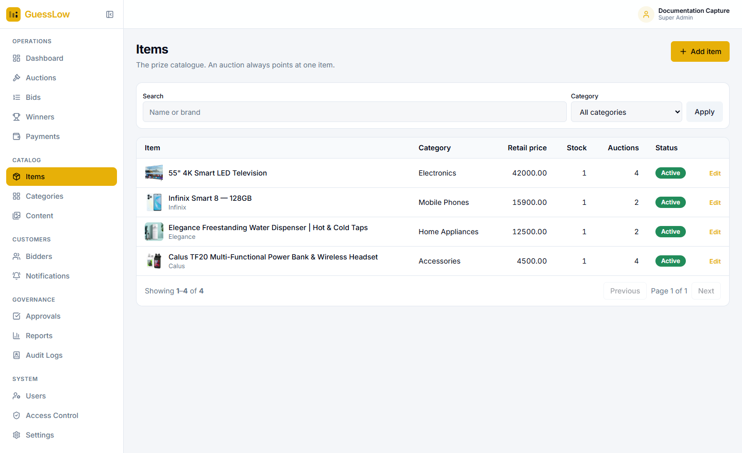
Figure 8.1: The prize catalogue.

8.1 Adding an Item
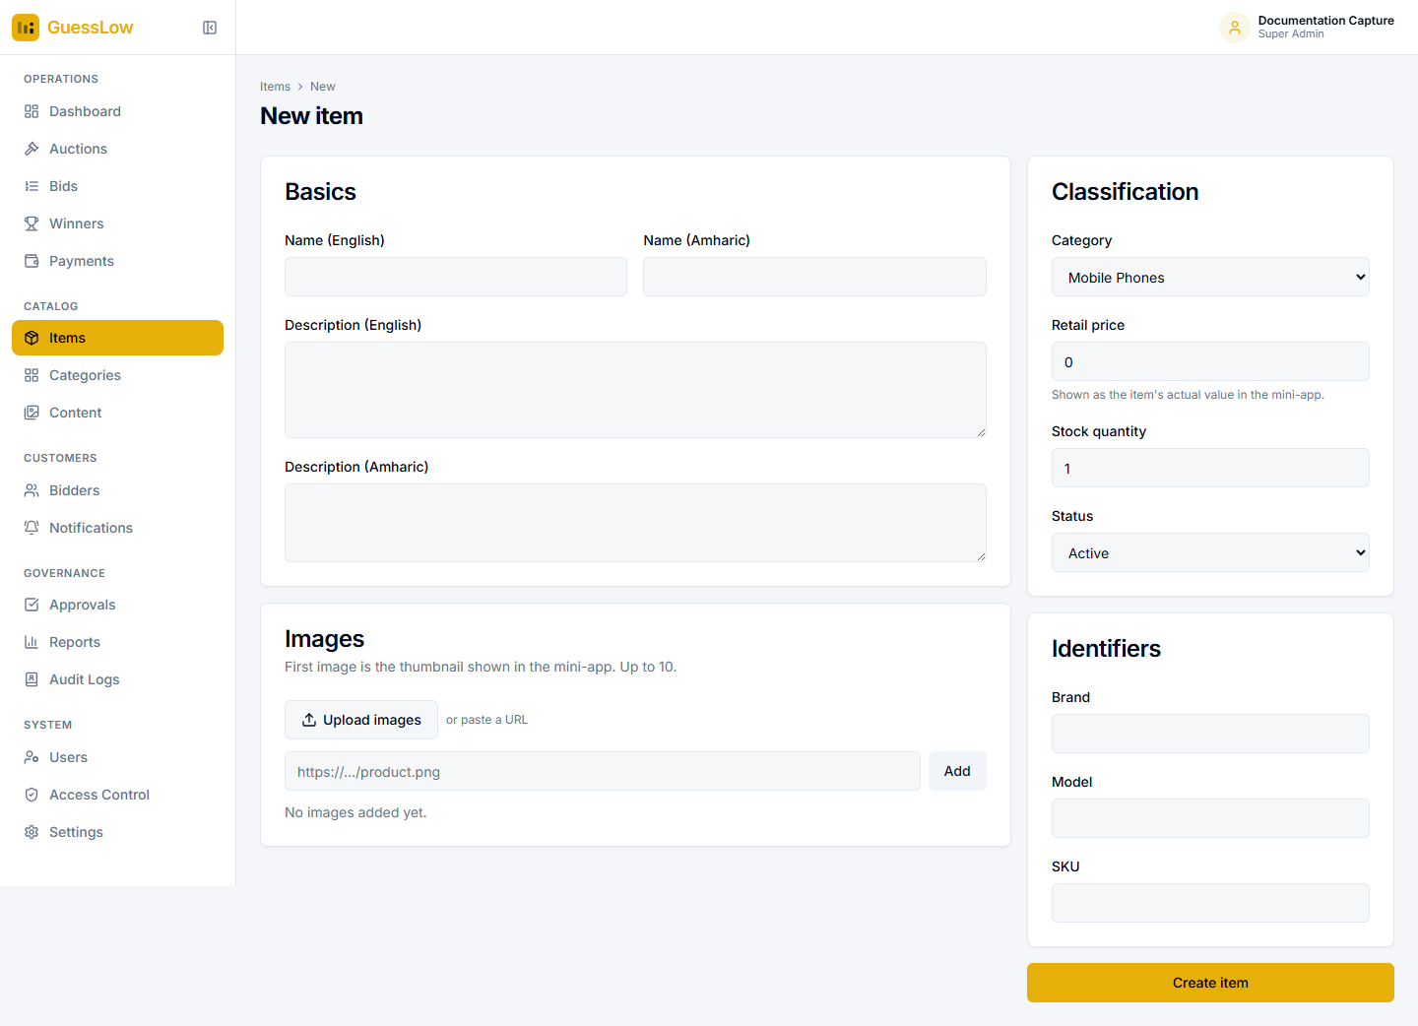
Figure 8.2: The New item form.
- Go to Items and select New item.
- Under Basics, enter the name and description in English and Amharic.
- Under Images, add up to ten pictures. The first is the thumbnail customers see. Use Upload images for a file from your computer, or paste a web address and select Add.
- Under Classification, choose the category, enter the retail price, the stock quantity, and whether the item is active.
- Under Identifiers, enter the brand, model and stock code.
- Select Create item.

The retail price is shown to customers as the item’s value, and is what the reports measure the prize cost against.
Items are deactivated, not deleted. An item still referenced by an auction cannot be deleted. Deactivate it instead, so past auction records stay intact.

8.2 Categories
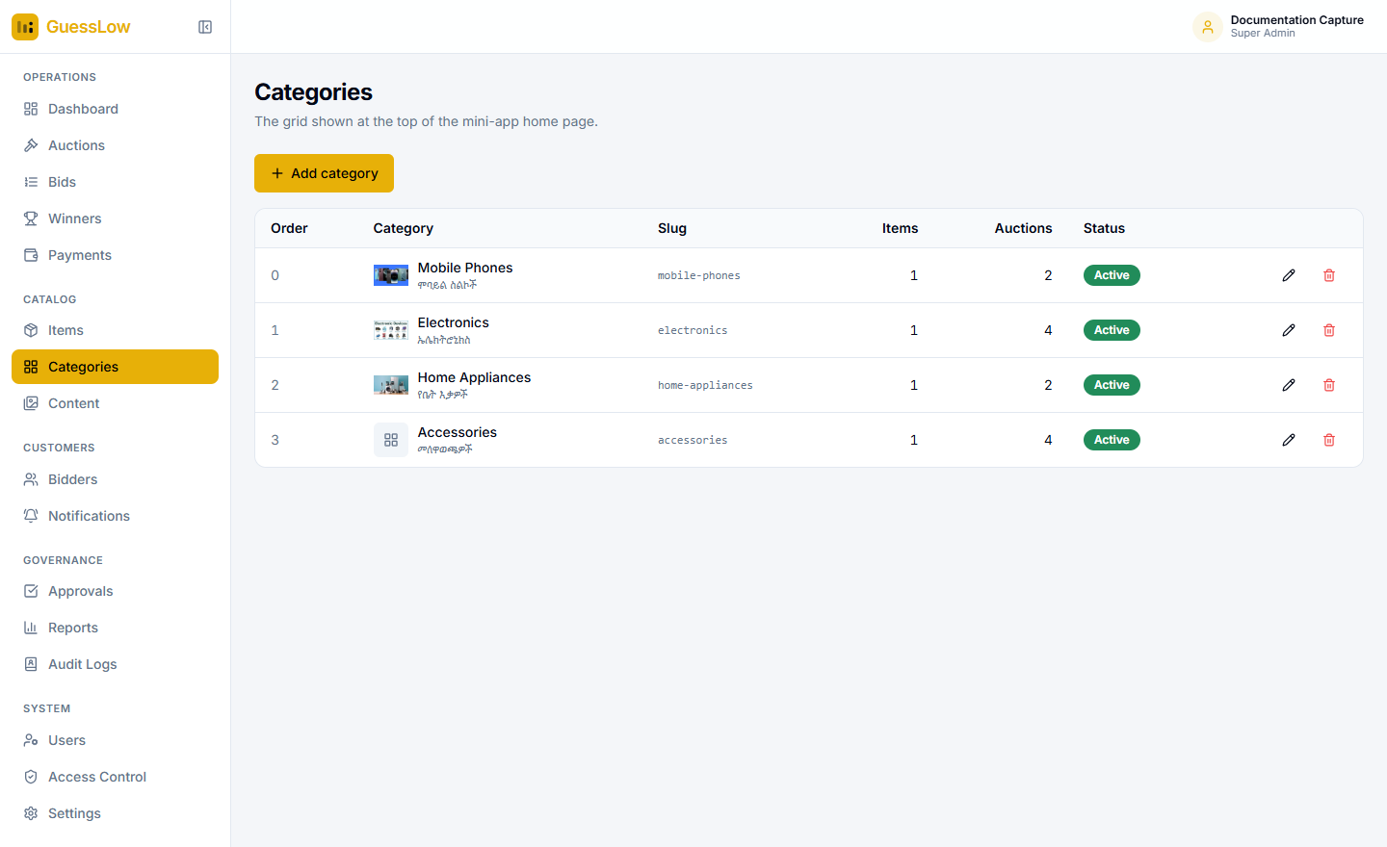
Figure 8.3: Categories — the top-level grouping customers browse by.

8.3 Uploading Pictures
Item photographs, category artwork and home banners all accept a file from your computer — drag it onto the drop area or use the picker — with the option of pasting a web address instead.
- Files may be up to 5 MB.
- PNG, JPEG, WebP, GIF and AVIF pictures are accepted.
- SVG files are refused, because they can carry program code.
- Every upload is recorded in the audit log.

9. Content
Content holds everything customers read in the mini-app. It is one page with five tabs, and a role can be given some tabs and not others.

9.1 Banners
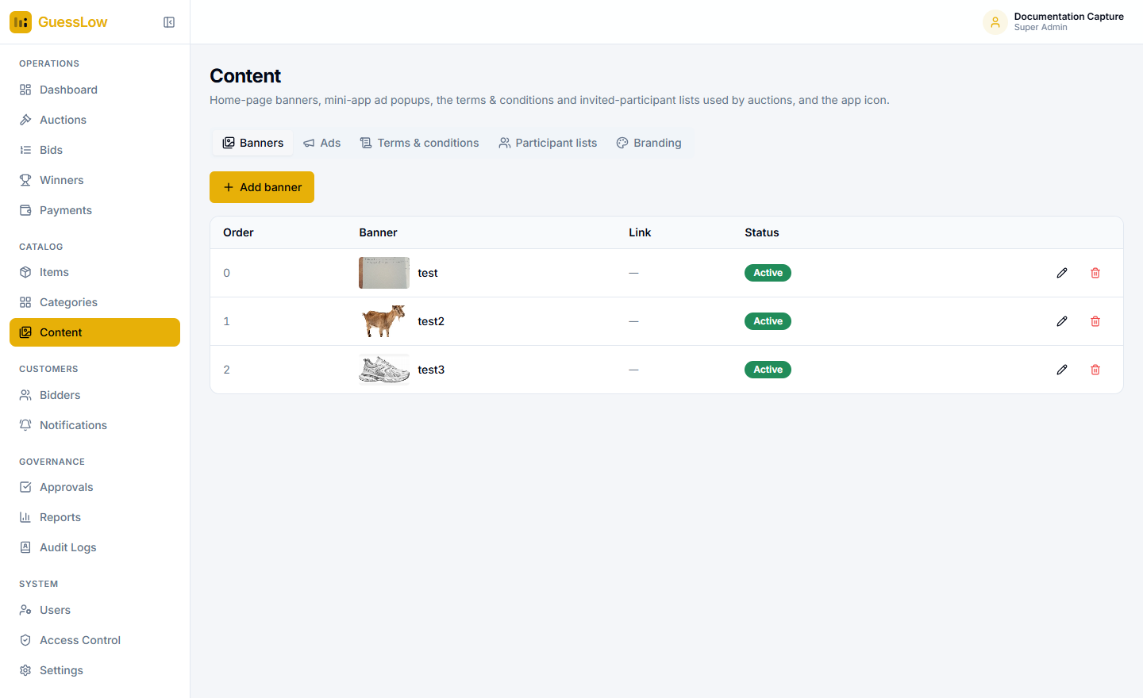
Figure 9.1: Banners — the promotional carousel on the mini-app home screen.

9.2 Ads
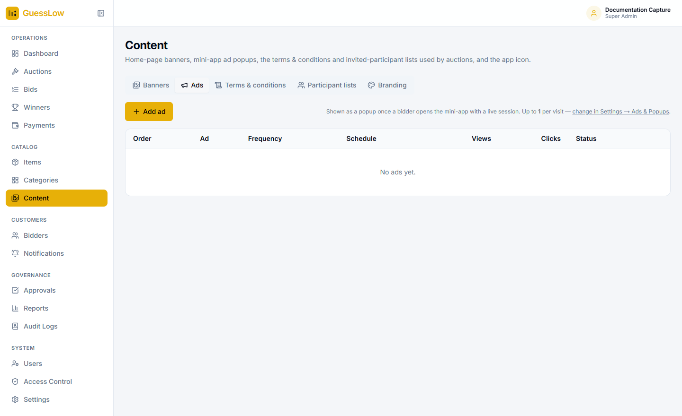
Figure 9.2: Ads — a popup shown when a customer opens the mini-app.
Each ad records how many times it was viewed and how often it was tapped. How frequently one appears, how many per visit and the delay before it shows are set under Settings → Ads & Popups.

9.3 Terms and Conditions
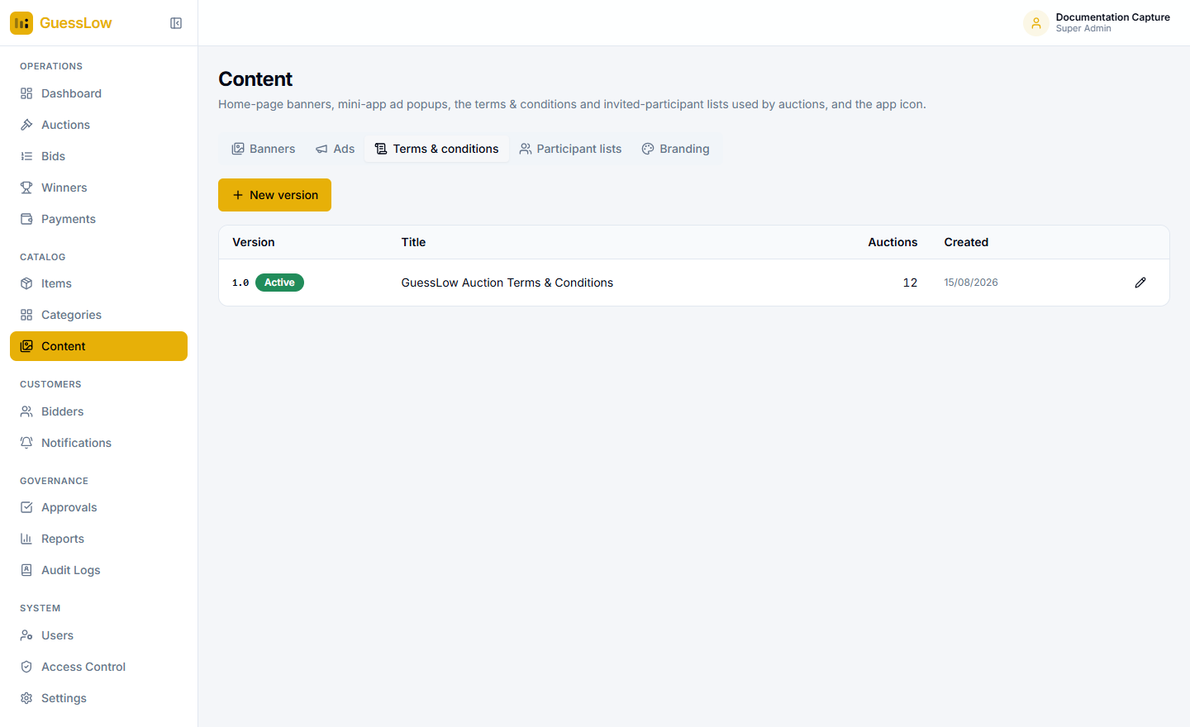
Figure 9.3: Terms and conditions, kept as numbered versions.
Terms are versioned for a reason. Each auction is pinned to the version that applied when it was created, so the terms a customer accepted are the terms on record. Publishing a new version never changes what was agreed on a past auction.

9.4 Participant Lists
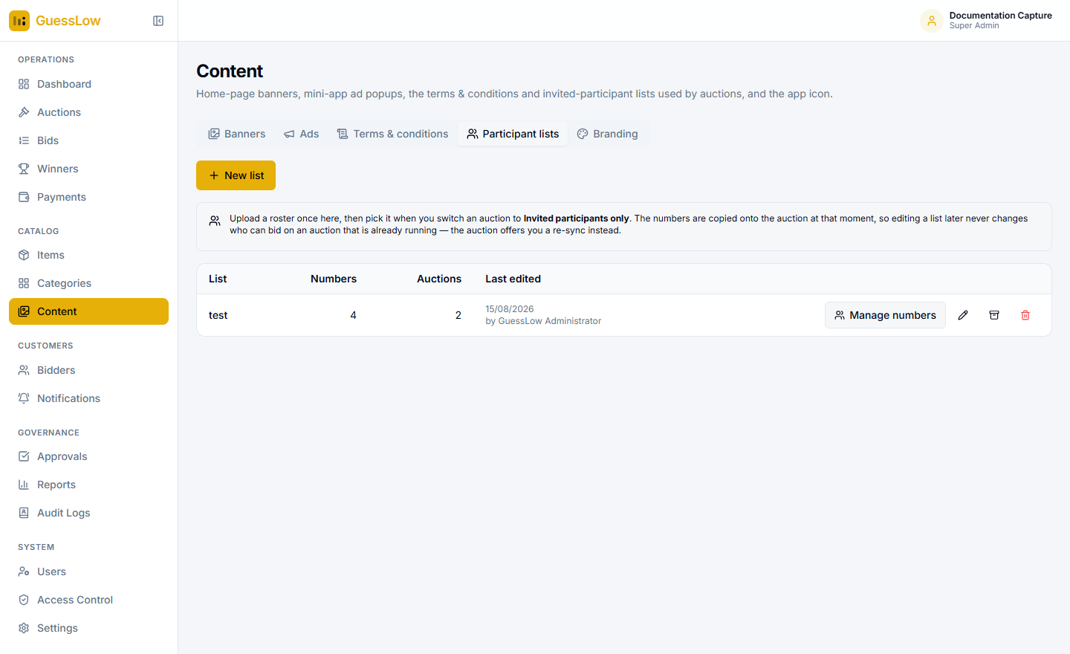
Figure 9.4: Participant lists — reusable rosters of phone numbers for invitation-only auctions.

9.5 Branding
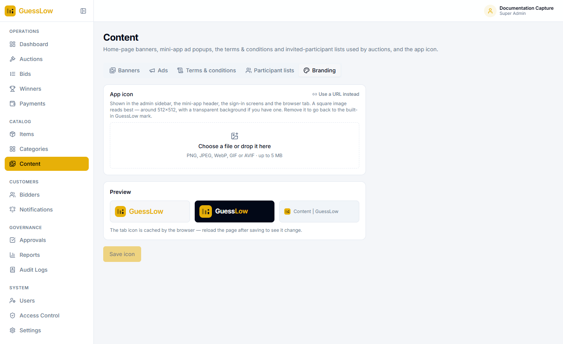
Figure 9.5: Branding — the logo and artwork the mini-app displays.

10. Bidders
Bidders are the customer accounts. An account is created automatically the first time someone opens GuessLow from the super app.
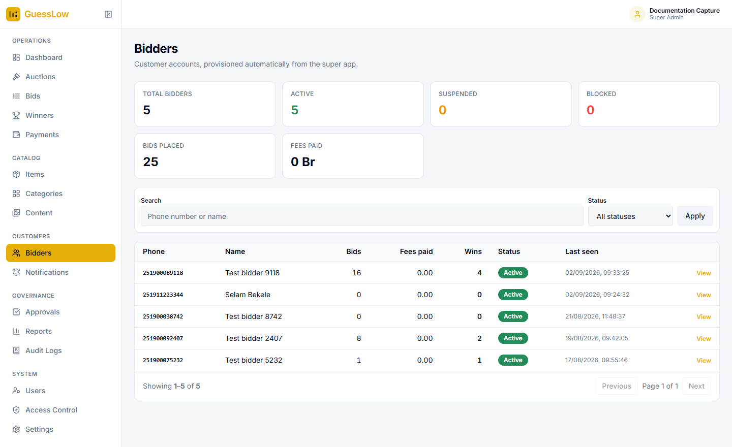
Figure 10.1: Customer accounts.
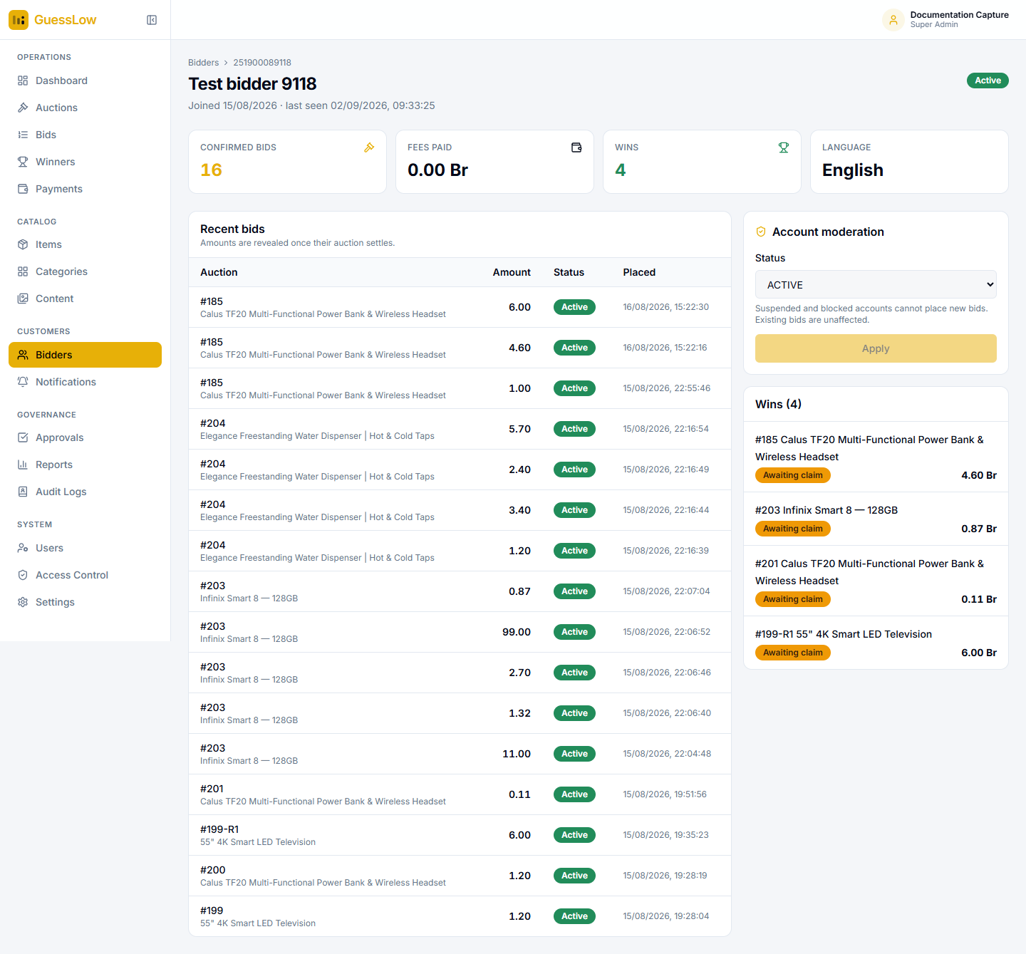
Figure 10.2: A customer’s record: their totals, every bid they have placed, and every prize they have won.
The tiles give confirmed bids, fees paid, wins and the language they chose. Recent bids lists every bid with its auction, amount, status and time — under the same rule as everywhere else, so amounts on running auctions stay hidden. Wins lists each prize with its claim state.

10.1 Suspending or Blocking an Account
- Open the customer’s record from the Bidders list.
- In the Account moderation panel, choose Active, Suspended or Blocked.
- Select Apply.

Moderation is not retrospective. Suspended and blocked accounts cannot place new bids, but bids they have already paid for are unaffected. Every moderation action records who made it.

11. Notifications
GuessLow sends customers an SMS at each important moment. The Notifications module holds the message templates and the record of what was sent.

11.1 Message Templates
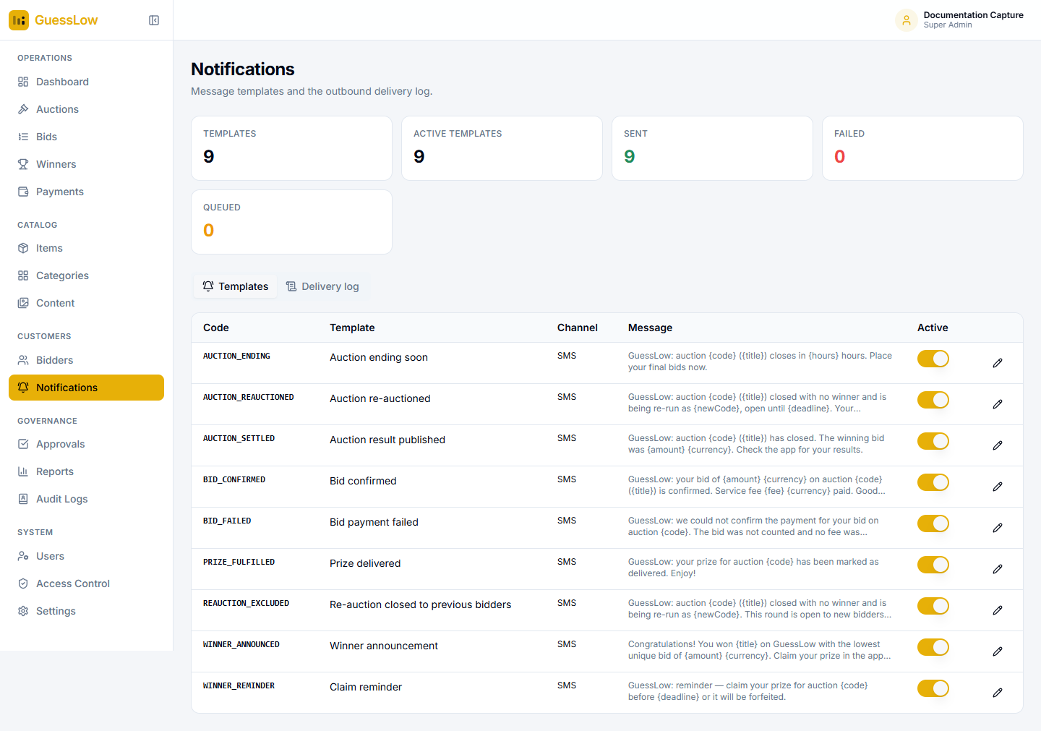
Figure 11.1: The nine message templates, each with its text and an Active switch.
Each row shows the template, the channel, the message and whether it is active. Select the pencil to edit it in English and Amharic. Messages are built from placeholders such as the auction code, the title, the amount and the deadline, which the platform fills in when it sends. Switching a template off stops that message without deleting it.
Message | Sent when
Bid confirmed | A customer’s fee is collected and their bid becomes active.
Bid payment failed | A fee could not be collected, so the bid was not counted.
Auction ending soon | An auction is close to its end time.
Auction result published | An auction has been settled.
Winner announcement | A customer has won and the claim window has opened.
Claim reminder | A claim window is running out.
Prize delivered | A prize has been handed over.
Auction re-auctioned | A new round has opened, with the free bids carried into it.
Re-auction closed to previous bidders | A new round has opened that the recipient may not take part in.

11.2 The Delivery Log
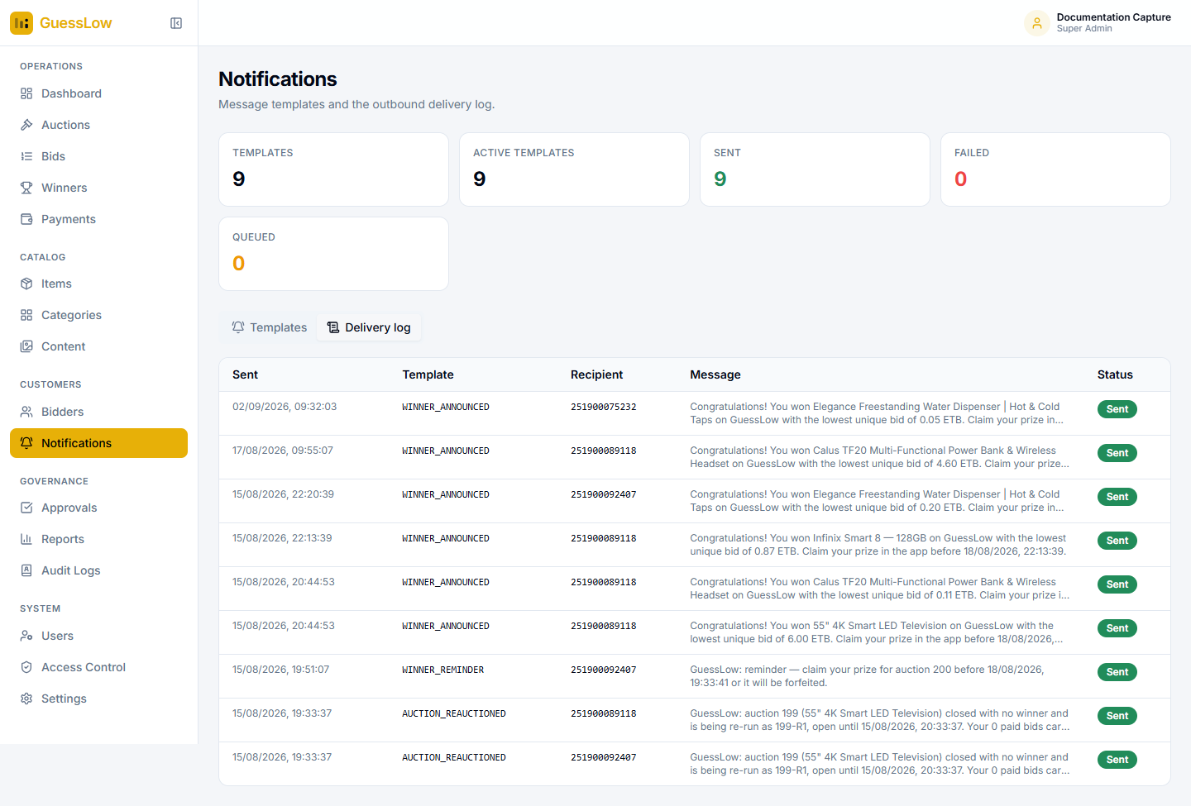
Figure 11.2: The delivery log — what was sent, to whom, and whether it arrived.
If messages are not arriving. Until the SMS provider is configured, messages are recorded here but not actually sent. If entries appear in this log, the templates and triggers are working and only the sending service is missing.

12. Approvals
Some changes are important enough to need a second pair of eyes. When maker-checker is switched on for an action, carrying it out creates a request here instead of taking effect immediately.
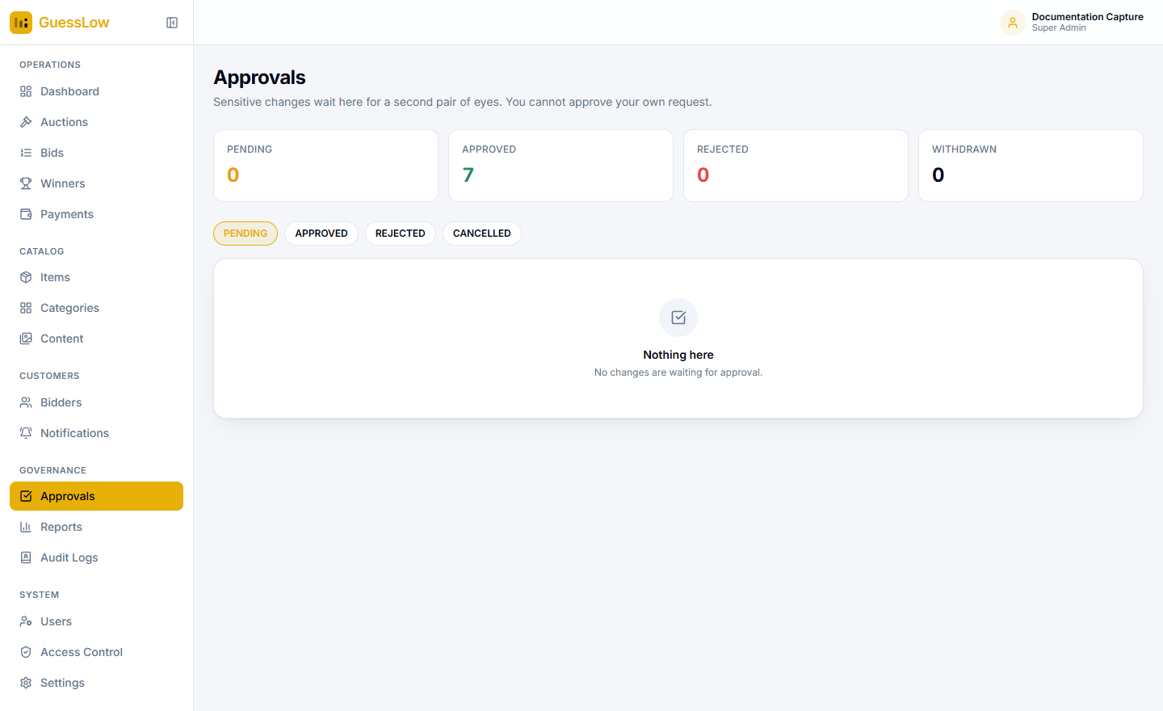
Figure 12.1: The approvals queue, with nothing currently waiting.
- Open Approvals and select the Pending list.
- Open the request and review the comparison showing exactly which fields would change.
- Select Approve to apply the change, or Reject to decline it.

You cannot approve your own request. The approve right is a second pair of eyes, and the platform enforces that literally.

Maker-checker can be switched on independently for publishing auctions, changing sensitive settings, and settling auctions. See Settings → Security & Governance.

13. Reports
Reports shows what the platform earned against what it gave away, over a date range you choose.
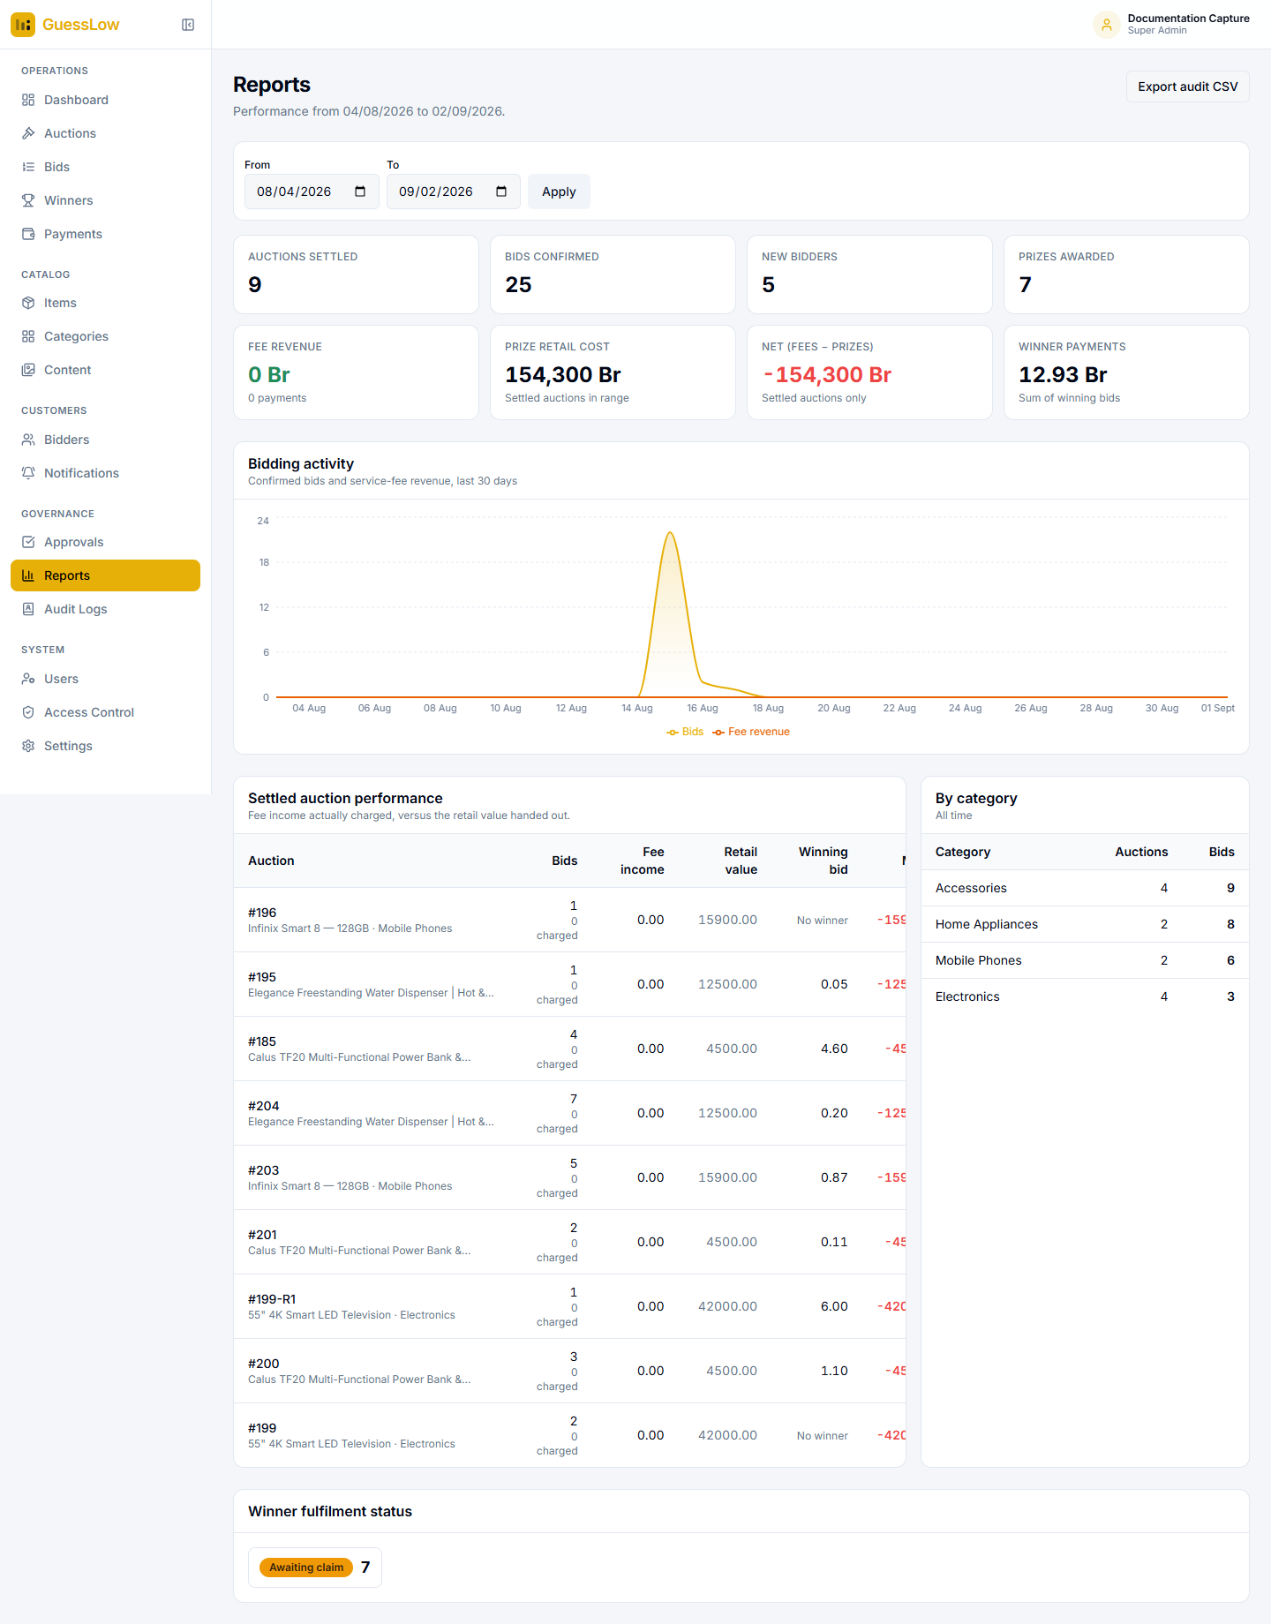
Figure 13.1: The Reports module. Fee revenue reads zero here because every bid in this environment was placed in a test session.
- Set the From and To dates.
- Select Apply. Everything below responds.
- Select Export audit CSV to take the figures away as a spreadsheet.

Figure | Meaning
Auctions settled | Auctions whose result was published within the range.
Bids confirmed | Bids whose fee was collected.
New bidders | Customers who joined within the range.
Prizes awarded | Winners produced.
Fee revenue | Service fee income actually charged.
Prize retail cost | Retail value of the prizes handed out.
Net (fees − prizes) | The margin. A red figure means the prizes cost more than the fees brought in.
Winner payments | The sum of the winning bids themselves.

Settled auction performance gives the per-auction detail: bids placed and how many were charged, fee income, the prize’s retail value, the winning bid and the margin. Auctions that produced no winner are marked accordingly. By category aggregates auctions and bids per category, and Winner fulfilment status counts winners by claim stage.
Read this page together with the Sanity check panel on the auction form. The two are the before and after of the same question — whether an auction’s economics work.

14. Audit Logs
Every privileged action, external call and movement of money is recorded and kept.
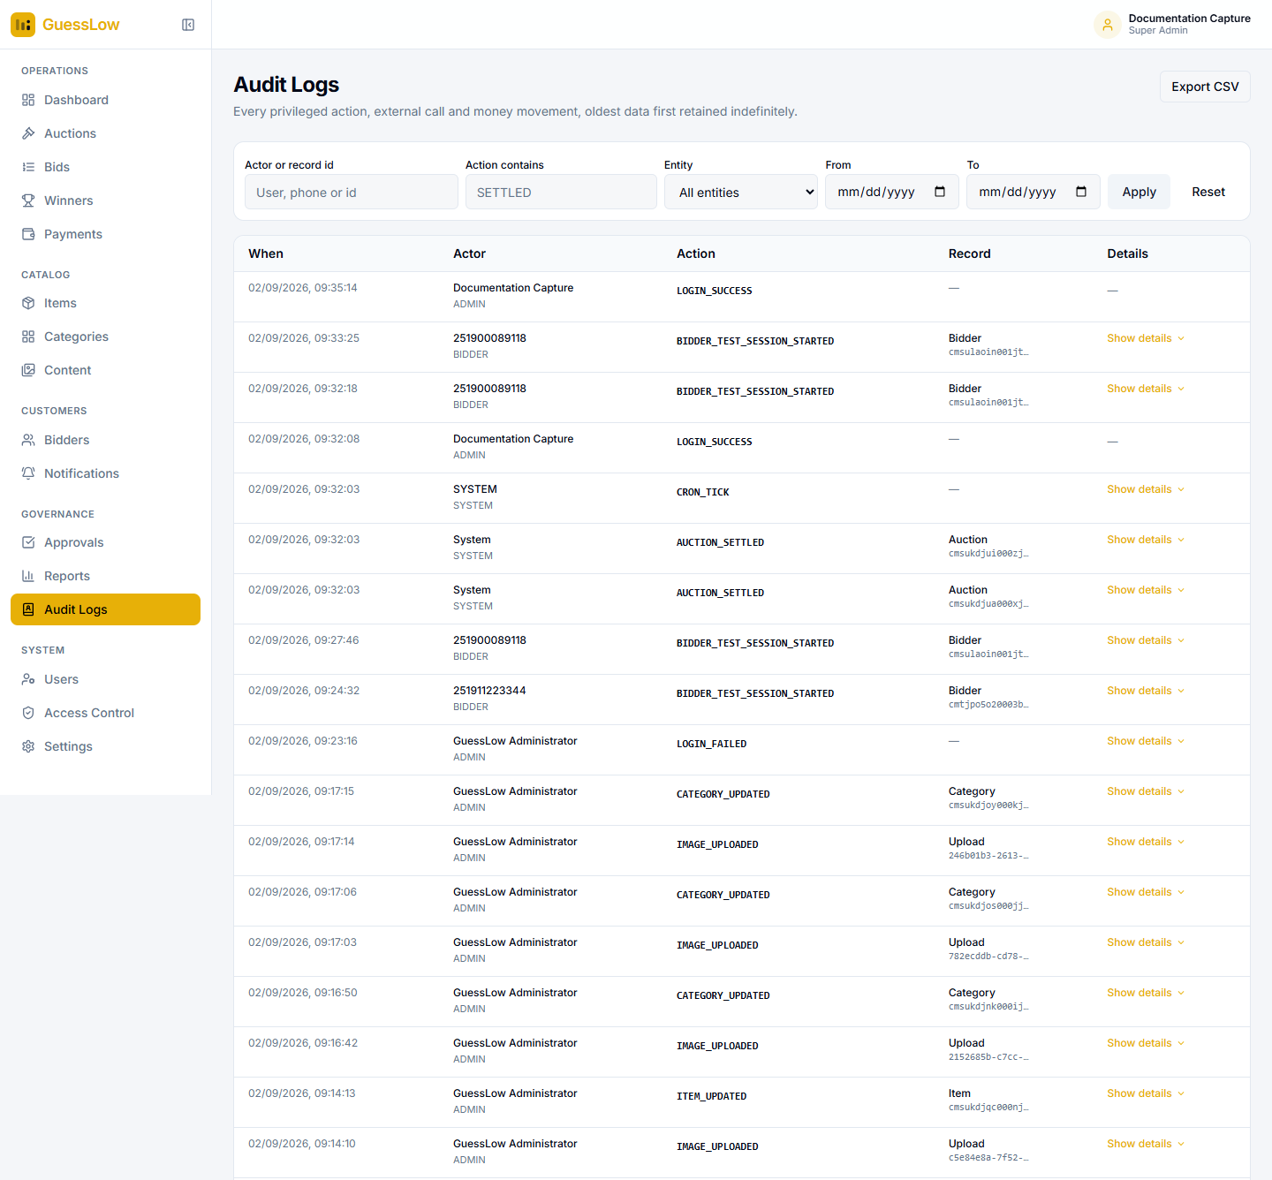
Figure 14.1: The audit log, with filters for who acted, what they did, on what, and when.
Filter by the person or record involved, by action — the Action contains box takes a fragment such as "SETTLED" — by record type, and by date range. Select Show details to expand a row, and Export CSV to take the filtered set away.
Entries cover staff sign-ins and failures, password changes, every catalogue and content edit, picture uploads, bid placement and confirmation, settlement, and automatic maintenance runs.
Bid amounts are deliberately absent. The audit log can be read while an auction is still running, so recording bid amounts here would place the live distribution one table away from people who must not have it. The bid record itself is the record, and the audit entry points at it.

The audit log is readable only by the Super Admin, Auditor and Compliance roles.

15. Managing Staff Accounts
Users and Access Control are available to the Super Admin role only.

15.1 Users
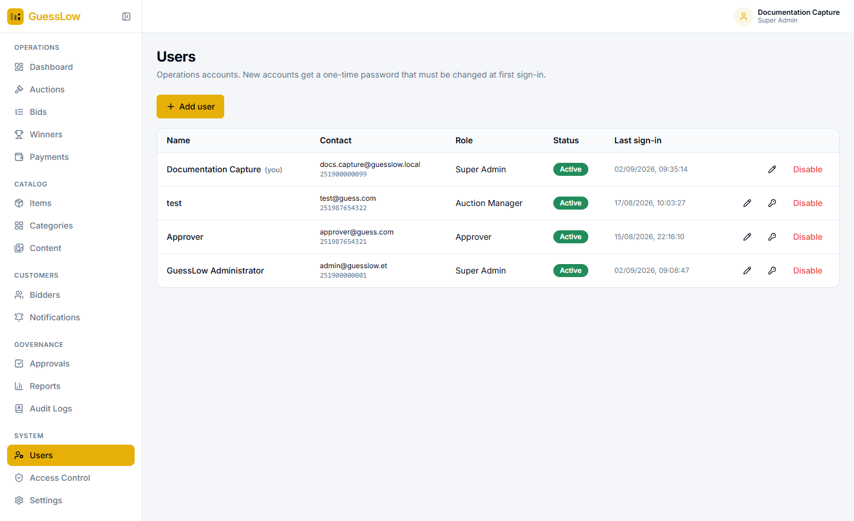
Figure 15.1: Console accounts, with their role, status and last sign-in.
Each row carries three actions: edit the account, issue a one-time password, and disable it. Your own row is marked and cannot be password-reset from here — use Change password instead.

Creating an account
- Go to Users and select Add user.
- Enter the person’s full name, work email address and phone number.
- Assign a role.
- Save. A one-time password is issued, which the account holder must change at first sign-in.

Removing access
Select Disable on the person’s row. This takes effect immediately — permissions are read afresh on every request, so access does not continue until their session expires.
You cannot lock yourself out. The last active Super Admin cannot be demoted, disabled or deleted. The platform refuses.

15.2 Access Control
A role is a grid of rights across the console. The rights are:
Right | What it allows
Read | Opening the module. Without it, the module does not appear in the menu at all.
Create | Adding new records.
Update | Changing existing records.
Delete | Removing records.
Approve | The second pair of eyes: settling auctions, deciding pending changes, and confirming payments by hand.

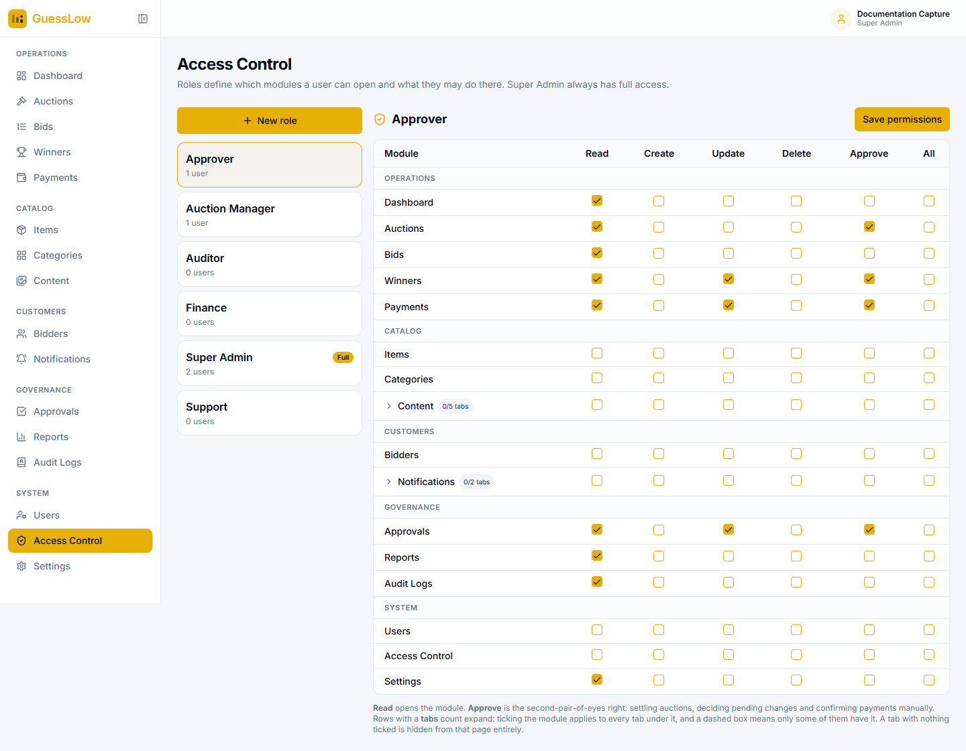
Figure 15.2: The role permission grid.

Changing what a role can do
- Go to Access Control and select the role on the left.
- Tick or clear the rights you want, module by module.
- Expand a row that shows a tab count — Content has five tabs and Notifications has two — to grant individual tabs.
- Select Save permissions.

Ticking a module applies to every tab beneath it. A dashed box means only some of the tabs are granted. A tab with nothing ticked is hidden from that page entirely. Changes take effect immediately.

The roles supplied with the platform
Role | Intended for
Super Admin | Full access. The only role that can reach Users and Access Control.
Auction Manager | Running the catalogue and the auction lifecycle.
Approver | The second pair of eyes on settlement, pending changes and manual payment confirmation.
Finance | Payments and reports.
Support | Customer-facing work: accounts, claims and questions.
Auditor | Read-only access, including the audit log.

Roles can be edited, and new ones created with New role.

16. Settings
Settings holds the platform-wide configuration. Every control carries its own explanation, so the page documents itself. Values set on an individual auction always override these defaults — settings only supply the starting point.
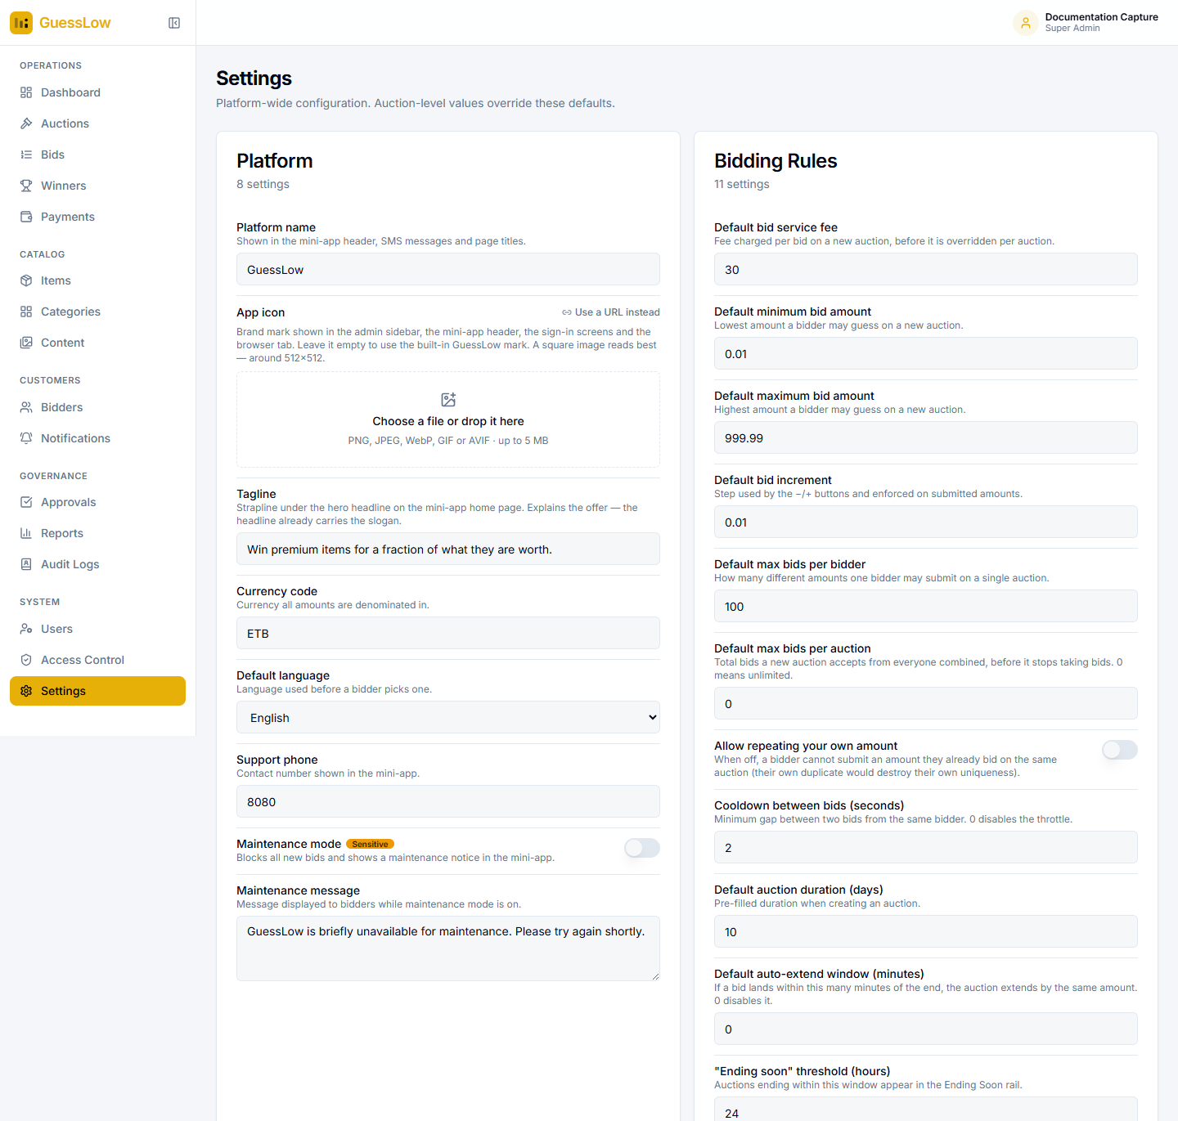
Figure 16.1: Settings, grouped by subject. Controls marked Sensitive route through approval when maker-checker is switched on.
Group | What it controls
Platform | Platform name, app icon, tagline, currency, default language, support number, and maintenance mode with its customer-facing message.
Bidding Rules | Default fee, bid range, increment, per-customer and per-auction limits, whether an amount may be repeated, the pause between bids, default duration, auto-extend and the ending-soon threshold.
Bid Visibility | When bid status becomes visible, and whether the list of bid amounts is published after settlement.
Winners & Claims | Automatic settlement, the grace period before it runs, the length of the claim window, how many runner-ups to record, and whether the winner’s masked number is shown publicly.
Re-Auction | Whether rounds are created and published automatically, the round limit, duration, start delay, who may join, and the minimum bids for a valid result.
Payments | Whether bid fees are charged at all, the merchant details, the payment timeout and refund flagging.
Ads & Popups | Whether ad popups appear, how many per visit, and the delay before one shows.
Notifications | The master switch for outbound messages, and a switch per event.
Security & Governance | Failed sign-in limit, lockout duration, and the maker-checker switches for publishing, settings and settlement.

Two settings deserve particular care. Maintenance mode blocks all new bids and shows customers a notice. Charge bid fees, when switched off, accepts bids without collecting any payment at all — intended for pilots and testing, never for live operation.

16.1 Keeping Auctions Moving
A background routine advances auctions from scheduled to live to ended, cancels unpaid bids that have timed out, settles ended auctions after the grace period, opens re-auction rounds, notifies winners and sends ending-soon reminders.
This routine is driven in three overlapping ways, so that a missed run is never harmful: a scheduled task, a background worker, and the console itself, which triggers a run whenever an auction page is opened. Awarding a prize never depends on a single one of them.
If an auction has ended but not settled. Check the Awaiting settlement tile on the dashboard, and simply open the auction — that alone triggers a run. If settlement is failing rather than merely waiting, the audit log will carry an entry explaining why.

17. Reference

17.1 Auction Statuses
Status | Meaning
Draft | Created, not visible to customers.
Pending approval | Waiting for approval before publication.
Scheduled | Published; start time not yet reached.
Live | Accepting bids.
Ended | Closed to bids; result not yet published. Amounts stay hidden.
Settled | Result published. Amounts are visible.
Cancelled | Withdrawn.

17.2 Bid Statuses
Status | Meaning
Pending payment | Placed, fee not yet collected. Does not count towards the result.
Active | Fee collected. Counts towards the result.
Failed | The fee could not be collected.
Void | Cancelled — usually a bid that waited too long for payment.
Refunded | The fee has been returned.

17.3 Payment Statuses
Status | Meaning
Pending | Waiting for the wallet.
Success | Collected.
Failed | Declined.
Expired | The customer did not approve it in time.
Reversed | Arrived after its bid was cancelled; flagged for refund.

17.4 Winner Statuses
Awaiting claim, Claimed, Verified, Fulfilled, Forfeited and Cancelled. See section 6.1.

17.5 Customer Account Statuses
Active, Suspended and Blocked. Suspended and blocked customers cannot place new bids.

17.6 Common Questions
Situation | What to do
An auction has ended but not settled. | Open the auction — that triggers a settlement run. Check the audit log if it still does not settle.
A bid was placed but is not counted. | It is probably waiting for payment. A bid only counts once its fee is collected. Check Payments for the transaction.
Amounts show as dots in the console. | That is correct while an auction is live or ended. Amounts open once it is settled. Use the Provisional result panel in the meantime.
A customer says they were charged twice. | Check the auction’s re-auction chain. Bids carried into a new round are recorded free of charge, so look at which round each fee belongs to.
Messages are not reaching customers. | Check the delivery log. If entries are there, only the sending service is missing.
An auction produced no winner. | Every amount was chosen by more than one person, or too few bids were received. Re-run the auction, or widen the bid range next time.

Approvals

Approvers Name Date Signature
EPMO Director: ______________________ _______________ __________
Project Owner: ______________________ _______________ __________

